**GAME DESIGN DOCUMENT**

GOD OF WAR II

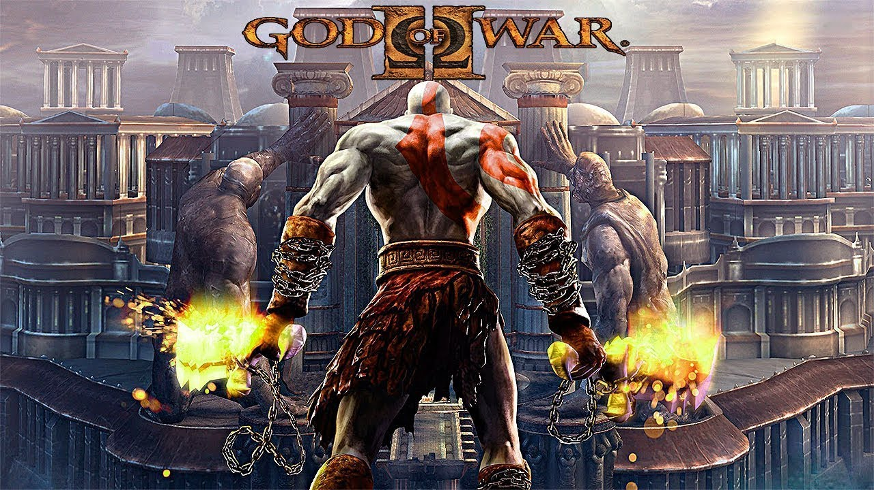

**Last Updated:**

28/11/2021

**Prepared By:**

Nikola Višekruna

**TABLE OF CONTENTS**

Game Analysis 3

Mission Statement 3

Genre 3

Platforms 3

Target Audience 3

Storyline & Characters 4

Gameplay 26

Overview of Gameplay 26

Player Experience 26

Gameplay Guidelines 26

Game Objectives & Rewards 27

Gameplay Mechanics 31

Level Design 36

Control Scheme 67

Game Aesthetics & User Interface 67

tasks and casts 70

# Game Analysis

God of War II is an action-adventure game with hack and slash elements. It's a third-person single-player video game viewed from a fixed camera perspective. The player controls the character Kratos in combo-based combat, platforming, and puzzle game elements, and battles foes who primarily stem from Greek mythology, including harpies, minotaurs, Gorgons, griffins, cyclopes, cerberuses, Sirens, satyrs, and nymphs.

# Mission Statement

God of War II is a hack-and-slash action-adventure video game and the sequel to the God of War video game for the PlayStation 2.

In GOD OF WAR II, you assume the role of Kratos, a Spartan warrior who achieved the status of a god after defeating the powerful Ares. But sitting upon the throne of Olympus did not quell Kratos' appetite for destruction - until the goddess Athena reminds him she was the one responsible for his position as the new god of war and punishes him by reducing him to the size of a human. Now, back on Earth, in the ancient Greek city of Rhodes, Kratos must prove he still has the goods to stay alive by fighting mythological creatures. In the first major battle, against Colossus, you must dodge his giant fists, catapult boulders (and even yourself) to launch attacks against his huge head, and use the twin blades chained to your wrists to fight off his minions.

# Genre

Action-adventure

hack and slash

# Platforms

PlayStation 2

PlayStation 3

PlayStation Vita

# Target Audience

Lovers of Hack and slash, action-adventure game genres

18+ gamers

# Storyline & Characters

**Character**: Kratos

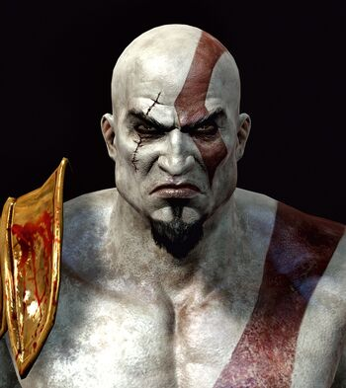

**Description**: The main protagonist of the game. At the start of God of War II, Kratos is the God of War after defeating Ares but not being released from his torment made his sorrow boil into hatred and anger for the Gods. He turns to his mortal army of Sparta to wage war on cities across the lands of Greece, which raises the anger of Zeus and the other gods. Soon, he finds he is betrayed by Zeus and reduced to a mortal and his powers are taken away from him. Kratos must then travel to the Sisters of Fate to exact revenge, take back his godly powers and destroy Zeus once and for all.

**Characteristics**: In the design process, Kratos was intended to look powerful and angry, showing little other emotion. He is depicted as a violent antihero who commonly shows little to no compassion for others.

**Misc. Info:** Powers and abilities: Vast Superhuman Strength, Superhuman Durability/Nigh-Invulnerability, Supernatural Resistance, Vast Superhuman Speed, Superhuman Agility, Vast Superhuman Stamina, Superhuman Senses/Precognition, Regenerative Healing Factor, Immortality, Shapeshifting, Power Absorption

**Character:** Athena

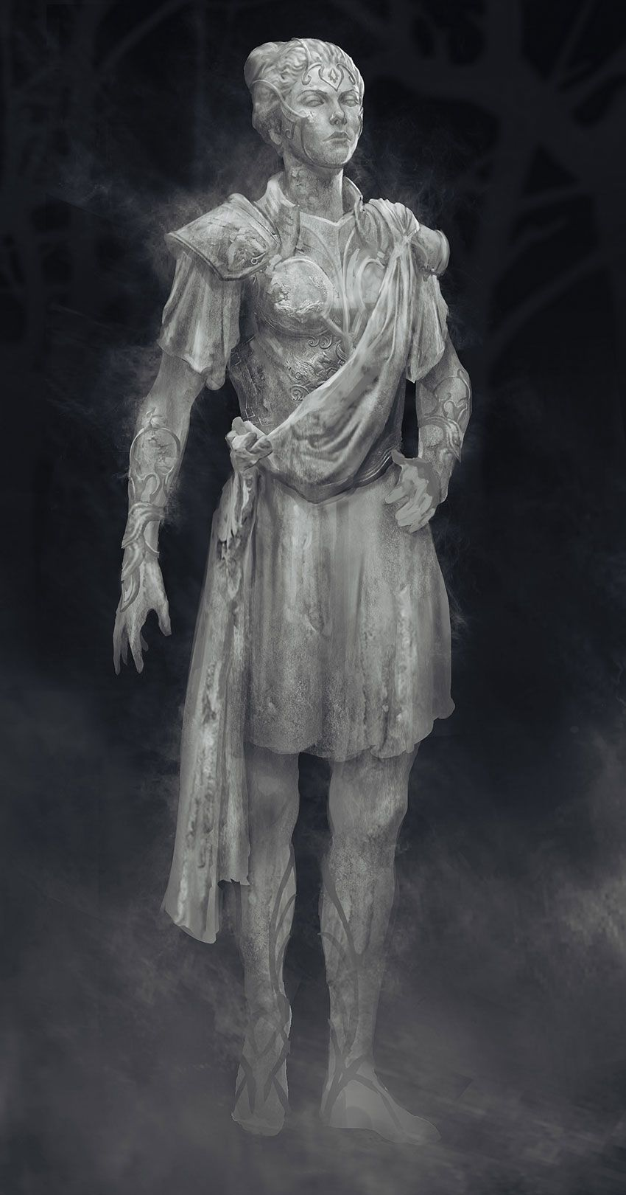

**Description:** The goddess of wisdom, defensive war and industry, and the deuteragonist. Though a constant companion in the first game, Athena only appears three times; to warn Kratos his actions are displeasing the other gods, while channeling herself through a statue, and to save Zeus by stepping in the way of Kratos' killing blow.

**Misc. Info:** Power and abilities: Astral Projection, Immortality, Invulnerable, Object Possession, Power Bestowing, Weapon Creation, Telekinesis, Flight, Wisdom

**Character:** Gaia

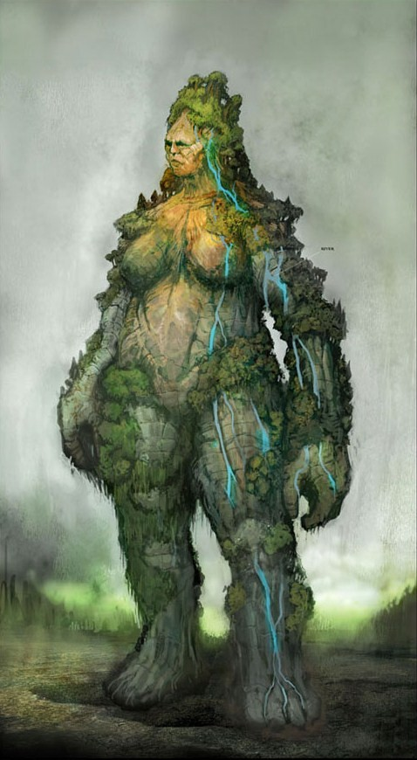

**Description:** Mother of the Titans, and connected to all things of the Earth and life. Along with the other Titans, she was banished in the War of the Titans, and seeing Kratos' quest for revenge on Zeus, offers to lend her power to his cause. She helps Kratos throughout his journey in hopes that together they can bring about the fall of Olympus. She also acts as the narrator of the game.

**Characteristics:** Gaia was once a caring and loving Titan, helping anyone no matter the cost.

**Misc. Info:** Power and abilities: Omniscience, Superhuman Strength, Superhuman Durability, Telepathy, Healing Factor, Immortality

**Character:** Last Spartan

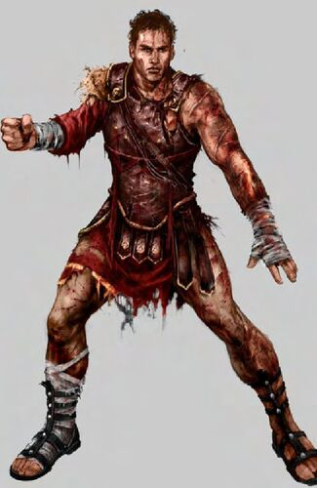

**Description:** In a dark room, Kratos duels an unknown warrior, who, when mortally wounded, is revealed to be his second-in-command, the young Spartan general.

**Characteristics:** He held a great loyalty to Kratos. He held hatred toward the gods after Zeus destroyed Sparta

**Character:** Lahkesis

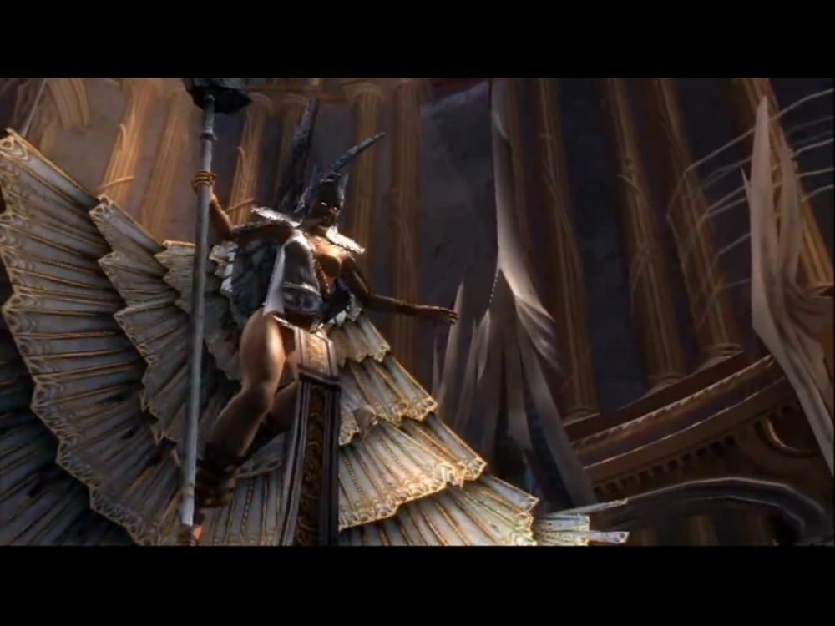

**Description:** The middle of the three Sisters of Fate bears a feathered robe and wings along with a staff. She mocks Kratos by telling him that she was the one responsible for deciding both the defeat of the Titans in the Great War and letting Kratos reach the Sisters. She refuses to accept Kratos and tells him that he will fail in his quest to change his fate.

**Characteristics:** Lahkesis is not as cruel as her older sister Atropos but still enjoys toying with the lives of mortals. She is very much proud of status as sister of fate.

**Misc. Info:** Powers and abilities: Lahkesis is very fast, has Superhuman Agility, Superhuman stamina, Superhuman durability, Premonition, Time manipulation, Destiny manipulation, High Resistance, Immortality and Flight

**Character:** Atropos

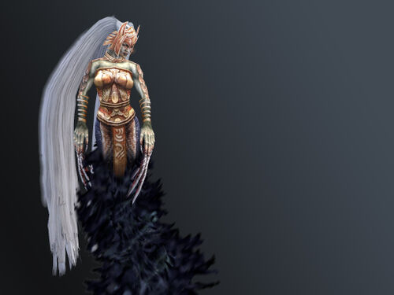

**Description:** The oldest (crone) Sister of Fate who was inside Lakhesis until she split off to fight Kratos. She mocked Kratos' attempt to change his fate, demonstrating her power by altering the event from the first God of War and attempting to destroy the Blade of the Gods so that Kratos would die by Ares' hand. Kratos is forced to fight in his own past in order to defeat her and preserve his existence.

**Characteristics:** Atropos is the cruelest of the three sisters. She believes that she can control anyone's life and is extremely proud of her status as a Fate.

**Misc. Info**: Powers and abilities: Chronokinesis, Destiny Manipulation, Flight, Immortality, Summoning, Superhuman Durability, Stamina and Strength, Claws, Vitrikinesis

**Character:** Clotho

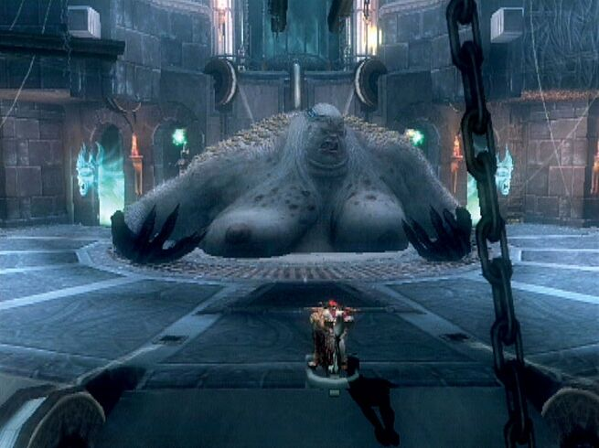

**Description:** The youngest Sisters of Fate that Kratos encounters, although she bears no resemblance to her sisters. She is a morbidly obese silkworm-like creature with multiple arms that sits within the multi-leveled Loom Chamber. She spins the thread of every mortal, god and titan. Kratos must defeat Clotho and learn how to work the loom in order to kill Zeus and change his fate.

**Characteristics:** Due to being the "creator of life", Clotho is proud of her status as a sister of fate and is always trying to keep everything in order, unlike her sisters who are always playing with the fate of mortals and gods alike.

**Misc. Info**: Powers and abilities: Superhuman Durability, Stamina and Strenght, Time Manipulation, Omniscience, Magical Perception, Multiple Arms, Immortality, Destiny Manipulation, Summoning

**Character:** Zeus

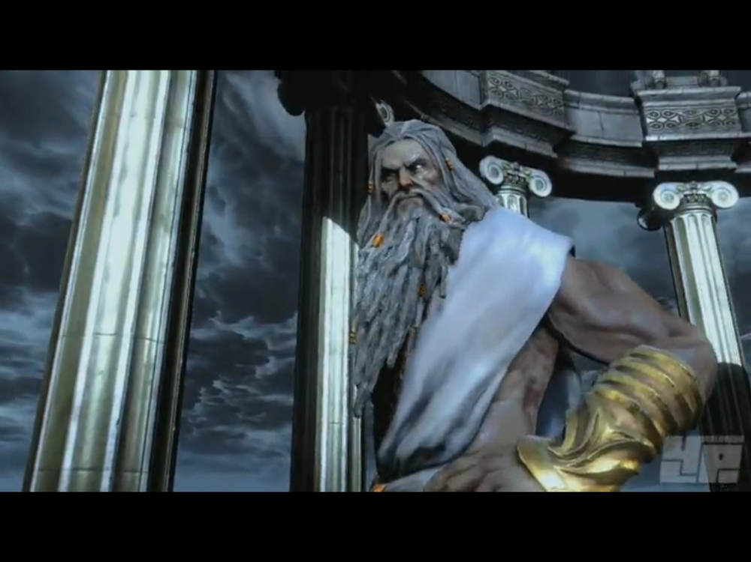

**Description:** The King of Olympus and the god who created the Blade of Olympus, and the main antagonist of the game. He is the father of Ares, Athena and Kratos. He betrays Kratos in the beginning.

**Characteristics:** Zeus has always been a cold, heartless being with little regard for anyone but himself.

**Misc. Info:** Powers and abilities: Superhuman Strength, Speed, Durability and Stamina, Flight, eather Control, Immortality, Teleportation, Portal Creation, Regeneration, Shapeshifting, Mind Imprisonment, Astral Projection, Power Absorption, Weapons Forgery

**Character:** Rhodes Soldier

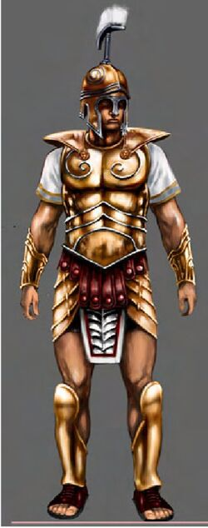

**Description:** These warriors are mere mortals and are no match even for weakened Kratos.

**Character:** Rhodes Archer

**Description:** Archer of the Rhodes army.

**Character:** Undead Legionnaire

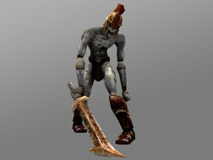

**Description:** The undead warriors return, but not as usual as in God of War.

**Character:** Undead Archer

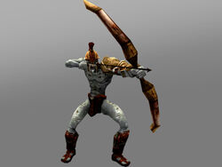

**Description:** Undead warrior with a bow returns

**Character:** Cursed Legionnaire

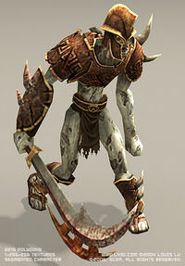

**Description:** The strongest version of the Undead Legionnaires

**Character:** Cursed Archer

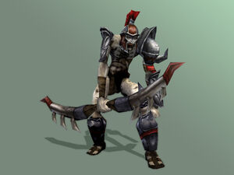

**Description**: The strongest version of the Undead Archers

**Character:** Legionnaire Captain

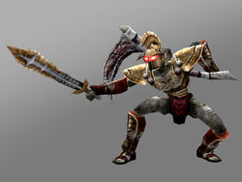

**Description:** The most powerful type of Legionnaires

**Character:** Hades Legionnaire

**Description:** The different version of Legionnaire Captain

**Character:** Fates Sentry

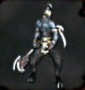

**Description:** The Satyr-like worshipers of Fate, and the most common enemies of the game

**Character:** Fates Guardian

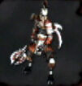

**Description:** The stronger version of Fates Sentry

**Character:** Hades Fiend

**Description:** Dangerous feminine undead warriors that can create fireballs, and throw them from a distance.

**Character:** Cursed Remains

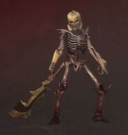

**Description:** These resurrected skeletons can only be defeated by being completely shattered

**Character:** Fates Juggernaut

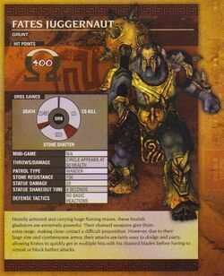

**Character:** Hades Juggernaut

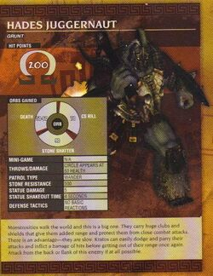

**Character:** Wraith of Athens

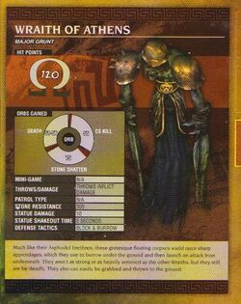

**Character:** Wraith of Asphodel

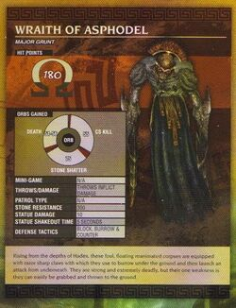

**Character:** Satyr

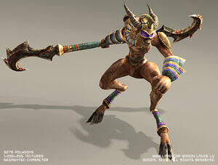

**Description:** Powerful warriors armed with a staff

**Character:** Satyr Champion

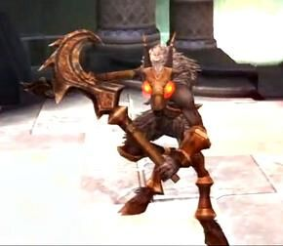

**Description:** The strongest version of the standard Satyr

**Character:** Beast Lord

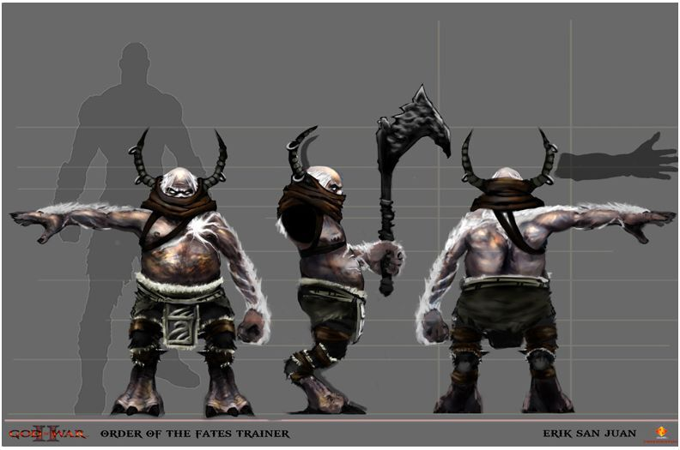

**Description:** Small, but dangerous Satyr-like servant of Fates. It can summon Cyclops, and take control over them

**Character:** Barbarian Mercenary

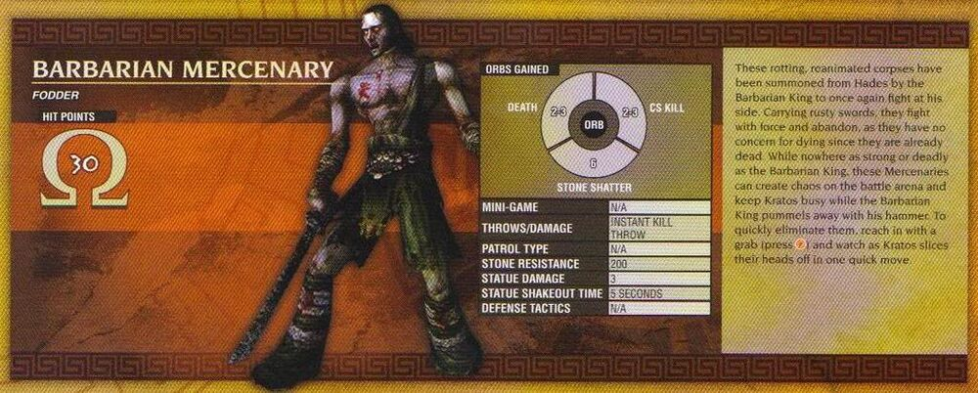

**Character:** High Priest of the Fates

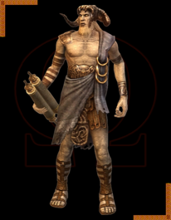

**Description:** These enemies are spell-casters who can teleport, summon more enemies, and drain Kratos' magic

**Character:** Harpy

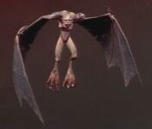

**Character:** Cursed Harpy

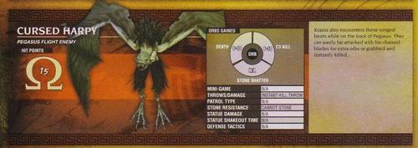

**Character:** Hades Harpy

**Description:** Harpy covered in flames

**Character:** Nymph

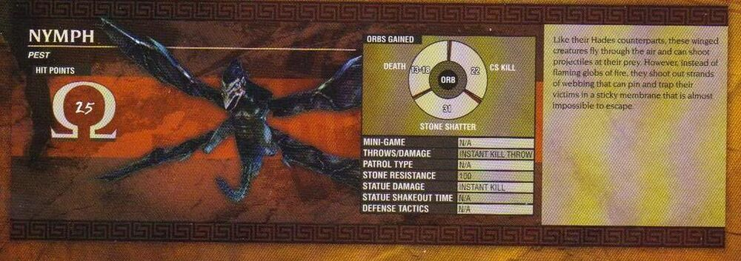

**Character**: Hades Nymph

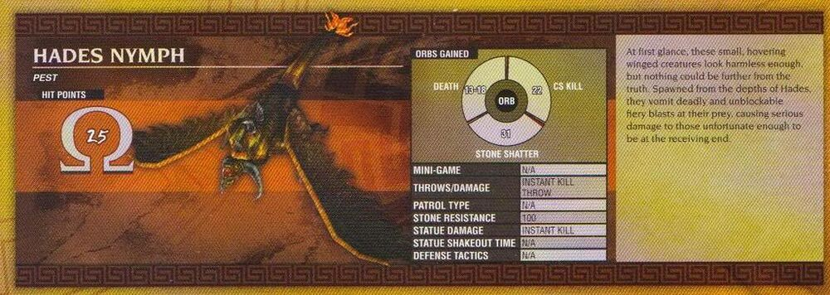

**Character:** Minotaur Grunt

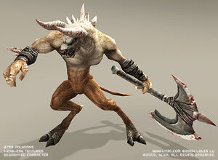

**Description:** The standard Minotaur

**Character:** Erebus Minotaur

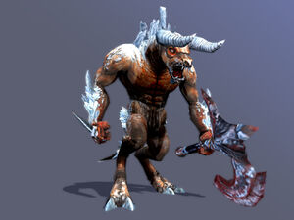

**Description:** Minotaur covered in ice

**Character:** Hades Minotaur

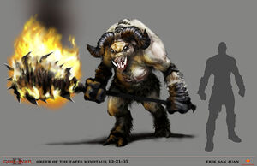

**Description:** These fat Minotaurs are unlike the other members of their kind

**Character:** Titan Minotaur

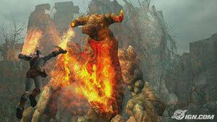

**Description:** The strongest of Kratos' enemies on Island of Creation, these ancient, stone beasts are formidable opponents.

**Character:** Cyclops Tyrant

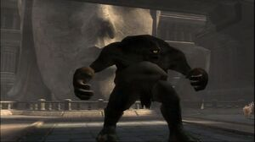

**Description:** UnarmedCyclops

**Character:** Cyclops Berserker

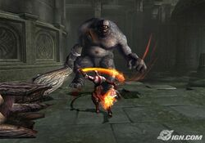

**Description:** Cyclops with a giant tree trunk

**Character:** Cyclops Brute

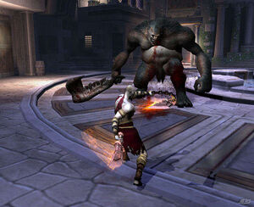

**Description:** Cyclops with a giant jawbone

**Character:** Gorgon

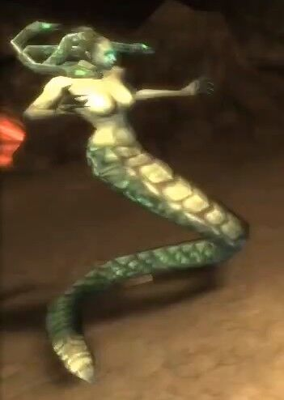

**Description:** The standard Gorgon

**Character:** Gorgon Assassin

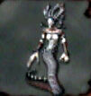

**Description:** A more dangerous version of the standard Gorgon

**Character:** Gorgon Queen

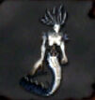

**Description:** The most powerful type of Gorgon

**Character:** Desert Siren

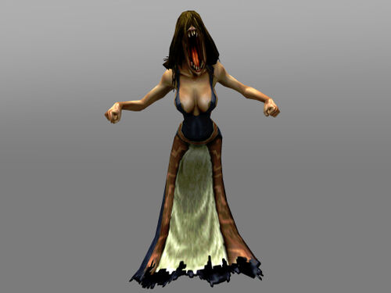

**Description:** Singing beasts

**Character**: Siren Widow

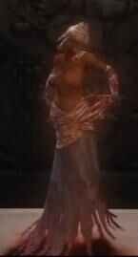

**Description:** The Sirens of Island of Creation are different from the ones Kratos encountered earlier

**Character**: Wild Cerberus

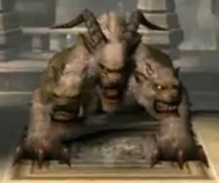

**Description:** Cerberus with horns in the middle head

**Character**: Mole Cerberus

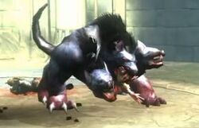

**Description:** The strongest version of the Wild Cerberus

**Character**: Cerberus Breeder

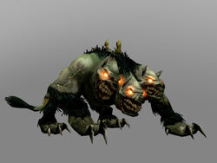

**Description:** The standard Cerberus

**Character**: Cerberus Seed

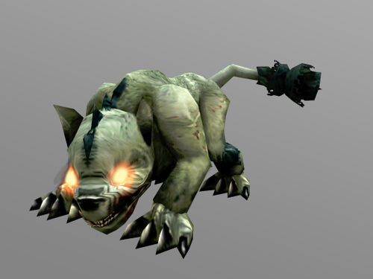

**Description:** The puppy-like demonic dogs

**Character**: Rabid Hound

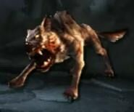

**Description:** Monstrous dogs that guards the Island of Creation

**Character**: Wild Boar

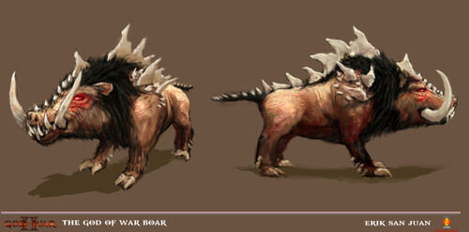

**Description:** Aggressive creatures native to the Island of Creation

**Character**: Griffin

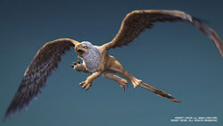

**Description:** Gigantic creature which patrol the waters around the Island of Creation

**Character**: Griffin Rider

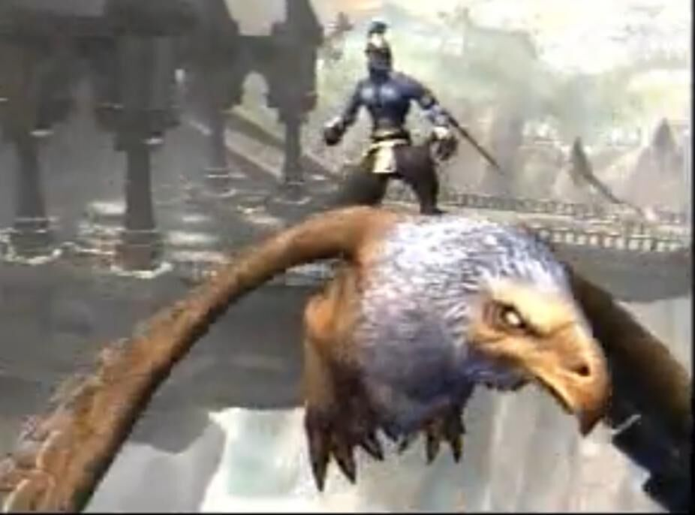

**Description:** The pilot of the Griffins

**Character**: Raven

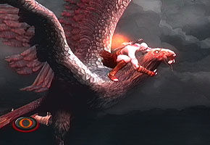

**Description:** Unique creatures (and challenges) Kratos faces and kills during the ride on Pegasus

**Character**: Colossus of Rhodes

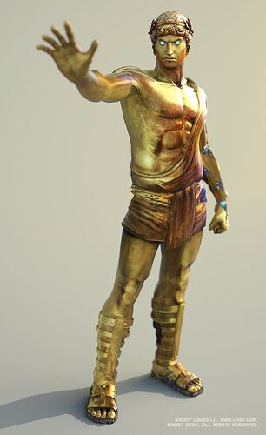

**Description:** The first boss in the game. It is brought to life by Zeus (disguised in the form of an eagle) who drains Kratos' power and gives it to the statue. When Kratos drains the colossus' power using the Blade of Olympus it begins to collapse. Kratos escapes through the mouth onto a platform. He is then crushed and nearly killed by the hand of the falling colossus.

**Misc. Info:** Colossus displays immense strength, enough to smash through large buildings and deal great amounts of damage to Kratos by pounding and swiping at him.

**Character**: Dark Rider

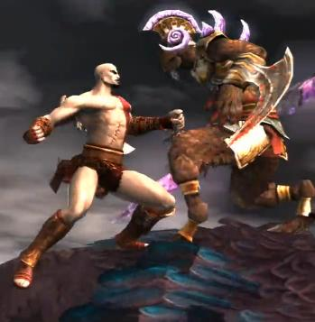

**Description:** This warrior pilots the Dark Griffin and is the leader of Griffin Riders. Armed with the Spear of Destiny, he protects the Island of Creation from any trespassers.

**Character**: Theseus

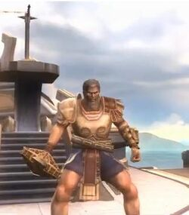

**Description:** A famous Greek hero, he wields a twin-bladed spear and can summon ice crystals and Frost Minotaur's. He serves the Sisters of Fate as the 'Horse master' for the glory of Zeus and keeps the key to the chapels on the backs of the Steeds of Time. After an extended battle, Kratos uses Theseus' own spear against him by impaling him to the door, using the key to open the door, then repeatedly smashing the door on his head until he dies.

**Characteristics:** Theseus has high opinion of himself and shows undying loyalty to Zeus and to The Sisters of Fate.

**Misc. Info:** As a Demigod he was gifted with superhuman strength, agility, stamina, ice/water manipulation endurance, accuracy, and durability.

**Character**: Barbarian King

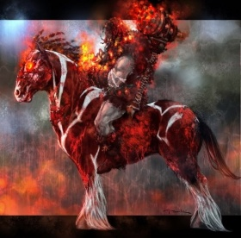

**Description:** The Barbarian King forcing Kratos to make a pact with Ares. In this game he is a powerful undead, a corpse riding a decrepit horse. After Kratos knocks the King off his horse and kills it, he uses his own hammer against him, smashing his head until it's nothing but a bloody stain

**Characteristics:** Ruthless barbarian king with a deep hatred for the Spartans, and especially their general, Kratos.

**Misc. Info:** Power and abilities: Archery, Horseback Riding, Size Alteration, Soul Summoning, Superhuman Strength, Teleportation

**Character**: Euryale

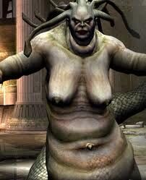

**Description:** This immortal being is Medusa's sister, a much larger, heavier gorgon. She praises the Sisters of Fate for luring Kratos to her temple. Her petrification energy is red, as opposed to most other Gorgons' energy being green. When defeated, her head can be used to turn enemies to stone

**Characteristics:** Euryale is one of the two immortal Gorgons, so she possesses a certain amount of invulnerability to mortal weapons. Euryale is capable of performing feats of great strength.

**Character**: Perseus

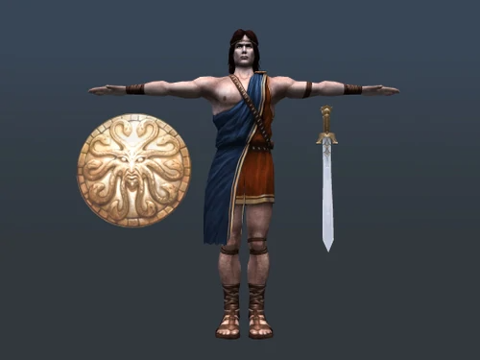

**Description:** The Greek hero appears to be on his own quest to seek the Sisters of Fate, to bring his love back from the dead. Perseus uses the Helmet of Hades that makes him invisible, a sling, a sword, and a reflective shield, all of which he received from various gods. He attempts to kill Kratos believing that the confrontation is a test to prove his worth for an audience with the Sisters. Kratos must first destroy his helmet to remove his invisibility then break his sword into pieces. Perseus is very confident in his own skill and quickly underestimates the abilities of Kratos. He also doesn't believe that Kratos should have been granted the chance to kill Ares as he finds this too much praise for the Spartan.

**Misc. Info:** Perseus possesses supernatural strength and agility. He also uses a large variety of items given to him by various Gods.

**Character**: Icarus

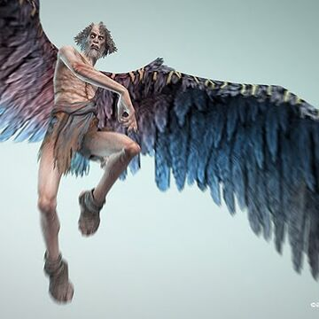

**Description:** Kratos runs into an elderly Icarus upon reaching the Great Chasm. He appears to have lost his sanity, reacting violently to Kratos' arrival.

**Misc. Info:** Power and abilities: Icarus wings

**Character**: Kraken

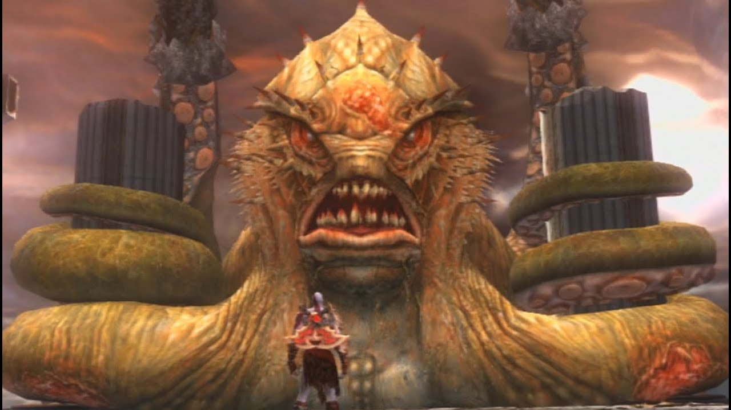

**Description:** The Kraken is a ferocious beast with several tentacles and a vicious appetite. Notably, she only displays four tentacles, two used to support her body by curling around the pillars in the area and two used for battle, which are equipped with a heavy spiked black armor-like exoskeleton. Her head has two large eyes, a massive, fanged mouth, and small spines or gills along its sides.

# Gameplay

## Overview of Gameplay

God of War II is a hack-and-slash action-adventure video game and the sequel to the God of War video game for the PlayStation 2.

The gameplay of God of War II is very similar to that of its predecessor. The player controls Kratos through a combination of combat, platforming, and puzzle game elements. It also keeps the concept of using minigames to perform bloody kills. Another element that returns from the previous game is Kratos ability to find Red Orbs to level up his weapons and magic and Gorgon Eyes and Phoenix Feathers to increase his health and magic meters.

## Player Experience

Like the previous God of War, Kratos receives numerous weapons and magical powers all throughout his quest, given to him by certain characters, or taken from his enemies. These items offer small enhancements in terms of gameplay over God of War, such as Icarus' Wings, which allows the player to glide short distances, the Golden Fleece, which allows players to repel projectiles, and the Blades of Athena, an item returning from the first game which now lets players swing from highlighted objects.

## Gameplay Guidelines

The game is based on Greek mythology and set in ancient Greece, with vengeance as its central motif. The player character is protagonist Kratos, the new God of War who killed the former, Ares. Kratos is betrayed by Zeus, the King of the Olympian Gods, who strips him of his godhood and kills him. Slowly dragged to the Underworld, he is saved by the Titan Gaia, who instructs him to find the Sisters of Fate, as they can allow him to travel back in time, avert his betrayal, and take revenge on Zeus.

## Game Objectives & Rewards

In the God of War II, Kratos will find Chests all throughout his quests. There are several different types of chests, which then yield different things when opened.

|  |  |
| --- | --- |
| Rewards | Penalties |
| There are hidden chests throughout the game that hide Gorgon Eye items. Collect six Gorgon Eyes and you'll be rewarded with an increased health bar.  Gorgon Eye  Phoenix Feathers are hidden in chests scattered throughout the game. Collect six feathers and Kratos will be rewarded with a larger magic meter.  Phoenix Feather  There are four earns to be found in the main quest, and two extra urns that can be earned in the Challenge of the Titans mode. To earn the last two urns, complete the Challenge of the Titans mode and earn ranks of Mortal and Spartan.  Urn of Gaia - Gain ten times the normal amount of Red Orbs.  Urn of the Gorgons - Weapons' attacks will turn enemies into stone on contact.  Urn of Olympus - Grants Infinite Magic.  Urn of Prometheus - Grants Infinite Rage of the Titans.  Urn of Fates - Extends the time of the combo meter allowing longer combos and slows down enemies for a few seconds.  Urn of Poseidon - Allows Cronos' Rage to be replaced with Poseidon's Rage magic.  urn  You can unlock a hidden costume in the game by collecting 20 Cyclops Eyes. Unlike other collectible items in the game, Cyclops Eyes are not hidden. Instead, they must be earned. When fighting a berserker cyclops enemy (the type that usually has a rider on its back), attack it to bring its health low. When a CIRCLE appears over the cyclops's head, grab the enemy and finish him off with the button-press mini game to earn a Cyclops Eye.  Challenge of the Titans - Complete the game on any difficulty.  Challenge 1 - Rip out the cyclops' eye before time runs out.  Challenge 2 - Kill 10 enemies in the air.  Challenge 3 - Stone shatter at least 25 enemies before time runs out.  Challenge 4 - Protect the translator from dying.  Challenge 5 - Collect 500 red orbs.  Challenge 6 - Defeat all the enemies without dying.  Challenge 7 - Defeat the enemies without taking damage.  Arena of the Fates - Complete Challenge Mode and earn the Titan rank.  Titan Mode - Complete the game on any difficulty.  Costume 1 and 2 – Complete the game on any difficulty  Costume 3 – Complete the game on God difficulty  Costume 4 and 5 – Complete the game on Titan difficulty  Costume 6 – Collect 20 Cyclops Eyes in the main game  Costume 7 – Earn the God ranking in Challenge Mode  Red Orbs - Red orbs are the most common type of orb, and they're used to level up Kratos' weapons and magic powers. Kratos can get them by defeating enemies, getting even more if he performs a special kill; by smashing just about anything around him with his blades; opening up Red Orb Chests; and racking up Combos.    Green Orbs - Green orbs refill Kratos' health meter when obtained. Kratos mostly gets them by finding and opening Green Orb Chests, but he can also sometimes get them by defeating enemies, most notably Minotaurs and Cyclopes. Killing minor NPC's found in certain area's also yields green orbs.    Blue Orbs  Blue orbs refill Kratos' magic meter when obtained. Kratos mostly gets them by finding and opening Blue Orb Chests, but he can also sometimes get them by defeating enemies, notably Gorgons. Slaying enemies with the Spear of Destiny always grants some magic orbs.    Gold orbs refill Kratos' Rage of the Titans only in God of War II. Kratos mostly only gets them by finding and opening rare Gold Orb Chests, but on rare occasions, he can find them by defeating enemies. Slaying enemies with the Barbarian Hammer always grants some golden orbs.    After Kratos frees Prometheus from his torment on Typhon's mountain, the latter burns in the Fires of Olympus and Gaia then gives the former his ashes. This grants Kratos the Rage of the Titans ability. | Lose collected orbs |

## Gameplay Mechanics

Weapons**:**

**Blades of Athena**: Magical blades bestowed on Kratos by Athena. Functioned the same as the Blades of Chaos. Given to Kratos as he ascended to Godhood, after Ares had taken the Blades of Chaos from him during their final battle.

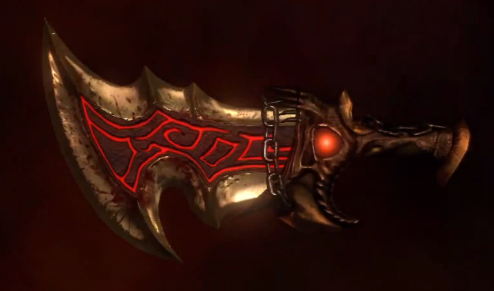

**Barbarian Hammer**: A slow, but powerful melee weapon originally wielded by the Barbarian King, Alrik. Kratos could deliver powerful slams and smashes, and also summon legions of souls.

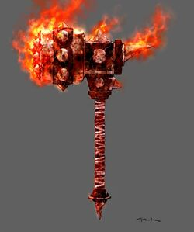

**Spear of Destiny:** A weapon originally used by the Dark Rider. Kratos could perform deadly swipes and stabs, and could also fire dangerous piercing projectiles at enemies.

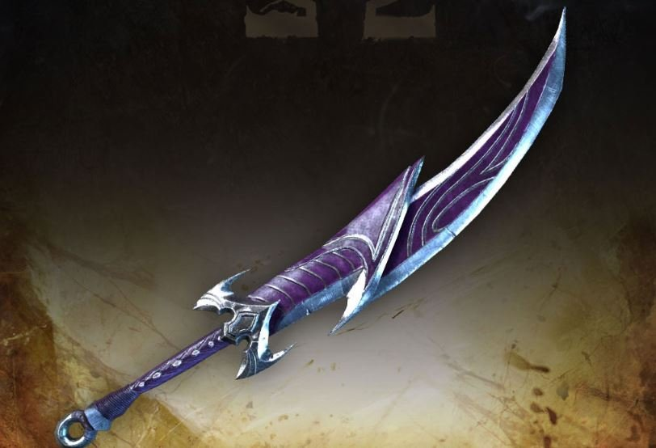

**Blade of Olympus:** A divine sword so powerful that it allowed Zeus to defeat the Titans. It was also one of the only known tools (along with Pandora's Box and the Gauntlet of Zeus) that had the power to harm and kill other Gods. The weapon could be powered up with experience Orbs to increase its power and add new attacks. However, the Blade of Olympus, normally a weapon that was provided solely by plot developments, could only be used during the fight with the Colossus of Rhodes, fighting Zeus in the last battle of the game, and Bonus Play.

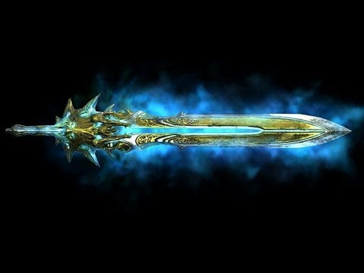

Magic:

**Poseidon's Rage:** A magic from God of War. Kratos used it in the first part of the game (at Rhodes), but lost it upon sacrificing his Godly Powers. However, Kratos could use that magic ability during Bonus Play if the Urn of Poseidon was unlocked and used. The urn switched Cronos' Rage with Poseidon's Rage.

**Typhon's Bane:** A magical bow-like weapon that allowed Kratos to fire rapid blasts of wind.

**Cronos' Rage:** An attack that used electricity to strike multiple targets via orbs of lightning. Higher levels spread further, attacked more targets, and even created an explosion at the end of its duration.

**Head of Euryale:** The severed head of Euryale, which could be used to turn enemies to stone.

**Atlas Quake:** A radial ground-pounding attack in which Kratos summoned strong earthquakes to smite opponents.

Relics:

**Poseidon's Trident:** Allowed Kratos to swim, dive, and breathe underwater infinitely.

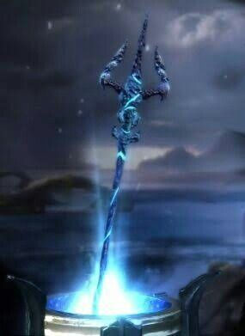

**Rage of the Titans:** Gained from Prometheus, that power could only be activated initially when a meter was filled either due to Kratos taking damage or collecting Gold Orbs. Activating the power increased Kratos' attack power for a short time and also allowed him to take less damage from enemy attacks. The player was allowed to activate and deactivate the Rage of the Titans whenever they wished.

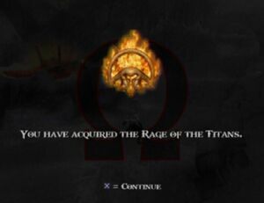

**Amulet of the Fates**: Allowed Kratos to slow down time when he was close to a Fates Statue.

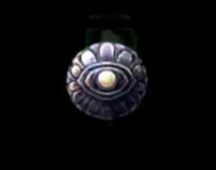

**Golden Fleece:** A golden armlet which Kratos could use to reflect attacks and projectiles back at their sender.

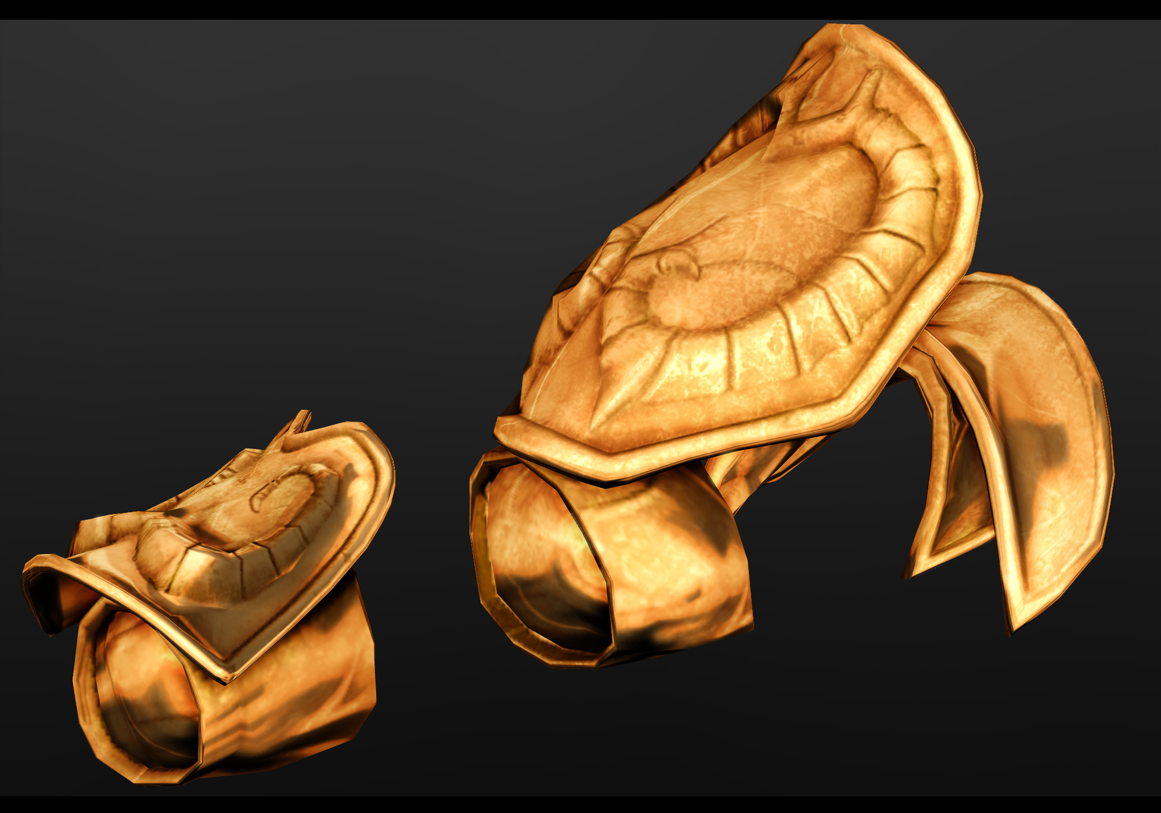

**Icarus Wings:** A pair of feathered wings that Kratos took from Icarus. With them, he could glide short distances while jumping and floating on air currents.

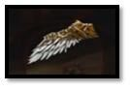

|  |  |
| --- | --- |
| **Character Attributes** |  |
| **Character** | **Movement Abilities / Actions Available** |
| Kratos | **Climbing controls:**  (walk or jump onto an object or wall that you can climb)  Left Analog Stick: Move  Left Analog Stick + Up: Quick Jump Up  Left Analog Stick + Back + X, X: Double Back Jump.  Left Analog Stick + Left/Right: Quick Jump Left/Right  Left Analog Stick + Left/Right + X: Jump to another wall.  Square: Light Jab.  Triangle: Long Strike  Circle: Grab Attack Enemy (Wall Grab)  **Rope Crossing:**  (Jump to the Rope to grab hold of it)  Moving Across: Left/Right  Quick jab: Square  Long Swipe: Triangle  Rope Gran: Circle  **Hanging Ropes:**  (Jump to the Rope to grab hold of it)  Facing Left/Right: Press Left/Right to face either way.  Swinging: Hold Circle to swing faster  Jumping off: X  Move up/Down: Hold Up/Down  **Firing Objects:**  Push (Side): R2 + Left Analog  Fire (Back): R2 + Back  **Boxes:**  Push: R2  Kick: R2 + X (Hold)  **Swimming:**  Swim Strait: Left Analog Stick  Swim Down: Square  Swim Up: X  Swim Charge: R1  **Combos**:  Cyclone of Chaos (L1 + SQUARE)  Plume of Prometheus attack (SQUARE + SQUARE + TRIANGLE)  Rampage of the Furies (L1 + CIRCLE) |
|  |  |
| **Game Modes** |  |
| Easy / Mortal  Normal / Spartan  Hard / God  Very Hard / Titan | **Easy** – reduced damage from enemies, enemies take more damage, for player to enjoy more story than combat  **Normal** – also for players to enjoy story with a reasonable challenges  **Hard** – demanding combat experience with skill to defeat enemies, enemies damage and health increased  **Very Hard** – this difficulty level require much more combat experience and skill, everything from hard mode but with more challenges |
| **Scoring System** |  |
| **Points/Coins/Stars/Grades/Etc.** | **How it’s Awarded & Benefits** |
| Red, Green, Blue and Gold Orbs | Red orbs are the most common type of orb, and they're used to level up Kratos' weapons and magic powers.  Green orbs refill Kratos' health meter when obtained.  Blue orbs refill Kratos' magic meter when obtained.  Gold orbs refill Kratos' Rage of the Titans |

## Level Design

God of War 2 is a seamless adventure with no defined stages. “Stages” has been separated into sections based on save points. Each save point has a unique name that you can see when you load your game.

Save Points:

**Rhodes** - You're immediately thrown into battle with a bunch of weak enemies. In your current form, they are no match for you, though the giant Colossus outside will soon pose a threat. When the nearest batch of enemies is dispatched, open the door to the left and continue to a hall with more enemies. When you've torn through the hall, the Colossus will smash a hole in the wall to the left. Jump through the hole and climb the ladder, then hop outside to engage the Colossus. You'll be surrounded by lesser enemies that you should probably deal with. To the left is a ballista set up with a large rock. Press R1 in front of the ballista to fire the rock inside. The Colossus will intercept the rock, showing you that you need to stun the Colossus before you can damage her. Return to the right where the enemies are and wait for the Colossus to smash her hand down. Unload your attacks on the hand, hitting her as much as possible before she retracts her hand for another slam attack. Repeat this until the Colossus is stunned. A brief cutscene will show the Colossus fade, as her eyes close in weakness. Jump back to the ballista to the left and press R1 to hop onto it. Mash the CIRCLE button to load Kratos as a projectile, then get ready to match the on-screen commands. Press the buttons that appear on screen carefully. If you get them all right, the Colossus will fling Kratos to another part of the stage.

**Rhodes Bathhouse -** You'll regain control in a pool of water. Immediately swim up to the surface of the bathhouse. You can jump out of the water and smash through some panels to the right (it'll take a lot of hits) to reveal an opportunity to earn some extra orbs. Approach the ladies and the peeing-boy fountain, then press CIRCLE to initiate a mini game. Match the on-screen button presses to earn a mess of orbs. Hop back into the large pool to the left and dive deeper, into the underwater tunnel. You'll need to press and hold the R1 button to charge up and smash through a wall before emerging on the other side of the bathhouse. To the right is a platform you can jump to with a ladder that leads to a save point. There's a grapple point to your left that you can swing on with the R1 button. Swing to the platform to the left and continue through a doorway (open it with R1) to engage some lesser enemies. After clearing through the baddies, continue forward, up a ladder, and be ready to mash the CIRCLE button to stave off an attack from the Colossus. To the left is a bare wall you can climb, though you should grab the two orb chests further left first. Climb the wall and you can make your way to a third chest on a balcony before climbing up to face off against the Colossus again. This second encounter with the Colossus is different than the first. There are no lesser enemies to deal with, but no ballista with which to fire Kratos towards the enemy. Instead, you'll need to fight the Colossus' hands to temporarily knock her out. The Colossus has an array of heavy punches she'll rain down on the courtyard you're in. After plenty of punishment, the Colossus will go lights out for a bit, face down on a platform to the right or left. Quickly run to the platform she's on using the grapple point between the two sides of the courtyard. Press CIRCLE in front of the Colossus to initiate another button-press mini game. Time all the button presses correctly and you'll deal some damage to the Colosus's face. You'll have to repeat the whole ordeal a second time, weakening the Colossus and finishing off with the button-press mini game. The Colossus will reject you again, and you'll appear in a new part of the stage.

**Rhodes Palace -** Jump up to open the doorway to the left and continue into the palace. Just around the first corner, you'll spot a crew of enemy archers aimed at you. There's a save point further down the hall, and just beyond that is a pack of enemies you'll have to fight. In the room beyond the enemies, look for a short block you can grab (it's to the left). Move the block right and position it over the floor switch near the closed gate on the left end of the room. The gate will open, letting you kick the block through the gate. The gate will naturally close when the block is kicked under, but you can raise the gate by standing on the floor switch before rolling (RIGHT ANALOG forward) under the gate. There's a second floor switch that opens a gate in front of you, but for now you should grab the block and drag it to the right. You move out to another hall at the far end of which is a trio of chests positioned high. There is a destructible eagle statue on top of the block that you'll have to break before you're able to jump on the box. Move the block in front of the wall and you can use it to jump up to the chests. Inside the center chest is an Urn of Gaia. Grab the block again and return it to the previous hall to place it on the second floor switch. There are some lesser enemies in the next hall. Take them out, then continue to another red orb chest and a floor switch that activates an elevator. Once at the top of the elevator, the Colossus will peek at you through a window. Hit them with your blades and the tower you're in will crash down.

**Eastern Ramparts** - You can climb the wall to the right by jumping up the ledges. Once at the top, you'll fight a number of lesser enemies while a few archers take pot shots from afar. When the path is clear, you can open the door at the far end to enter a courtyard with a set of narrow beams to traverse. There are archers in the courtyard below that'll try to tag you while you balance across the narrow beams. With the archers killed, look for a ladder near the beginning of the courtyard that'll let you return to the balance beam walk. You want to make your way to the save point up ahead, though there's a pair of red orb chests closer. Just beyond the save point is a hole in the floor. Drop down and take out the baddies in the small room before opening the gate ahead. Once through the gate, run fast, straight forward. The Colossus will pop up and smash the bridge you're on. Here, the Colossus has two main attacks. He'll either smash with his right hand or stab with his left stump. When the Colossus smashes with his right hand, jump just before he hits the ground to dodge the shockwave. When he stabs his left stump into the side of the cliff, watch the cracks that appear in the ground and stand away from them. A second later, damaging energies spew out of the cracks. When you can, make your way to the severed hand to the right. Press R1 in front of it to hurl the rock at the Colossus, temporarily stunning him. With the Colossus stunned, run over to the Blade of Olympus and hold R1 to pour your energy into it. You won't pull the blade out yet, but you will kickstart the process. Kratos will eventually let go of the sword as the Colossus comes to. Focus now on dealing damage to the Colossus, hitting his hands as they smash down near you. You can also rush the Colossus and hit his body from the edge of the cliff ahead. Eventually the Colossus will become stunned once again, letting you return to the Blade of Olympus to pour more energies into it. You'll have to do this all once more before fully freeing the Blade of Olympus from its hold in the ground. With the blade in hand, run up to the Colossus and attack his arm that's resting on the cliff. The Colossus will occasionally pull his left stump back and sweep across the cliff's edge with a beam-like attack. Before long, the Colossus will be stunned again. Press CIRCLE near him to jump into his, uh, insides. From inside the Colossus, you'll need to make your way upwards along the spiraling platforms, attacking occasional weak points of the structure that are highlighted by a glowing aura. In fact, the glowing aura surrounding some parts of the structure are more dangerous than the enemies. You'll find the first weak point in the structure pretty early. Just look for a walkway that leads to the center of the Colossus and press R1 to damage it. Further up the insides of the Colossus, you'll have to jump onto a horizontal rope and climb where no path leads. When you find a beam to balance across, look for a beam that leads left to another vulnerable part of the structure. You'll have to attack the center pillar a few times to break the chains around it before you can press R1 to stab the Blade of Olympus into the pillar. Keep moving upwards through the Colossus. Look for a part of the outside wall you can climb to reach the next platform with more enemies to fight off. You'll notice a bunch of beams surrounded in the blue aura, but no access to the center pillar. You can sidle along the central structure, moving left around the circular platform. You'll have to press R1 to drop down a bit and pass under the glowing beams before you can reach the vulnerable center pillar. Again, strike the pillar with your sword to break the chains away, then press R1 to stab the pillar. After the brief cutscene that shows the pillar's destruction, you'll be placed facing a rope that leads upwards. Before climbing the rope, look to your left. There's a wall you can climb that leads upwards to a Gorgon Eye chest. Climb the rope to reach the head of the Colossus. There's a ladder to the right that leads to a horizontal rope and a lever. The path along the rope is blocked by the blue beams coming in from the Colossus's eyes, and you'll need to take care of them before you can proceed further. Pull the lever and a large pendulum will lower. Drop down to the base of the ladder and strike the pendulum a few times with your sword to get it swinging. Climb back up the ladder and pull the lever again to raise the pendulum. The pendulum will rock back and forth, intercepting the blue beams from the eyes long enough for you to climb across the rope. Continue forward on the platforms to find the last weak spot inside the structure of the Colossus. Destroy it as you destroyed the last two, then quickly retreat along the crumbling platforms to escape through the Colossus's mouth. A brief scene will play out in which you can't help but be killed and sent to Hades. Quickly whip your chains to destroy the hands that reach out to grab Kratos. You'll knock health orbs from them with every strike, letting you rebuild your health bar. Climb upwards, jumping across gaps in the wall, to exit Hades and return to the surface of Rhodes.

**Return from Hades -** Examine the bodies of the fallen Spartans as one of them is still alive. After the brief conversation with the Spartan, walk over to the just-arrived pegasus and press R1 to hop aboard and trigger a flight scene. While flying on the pegasus, the controls change drastically. You still have two attack buttons but the jump button makes the pegasus rocket forward. The L1 and R1 buttons will let you dash side to side, an important ability when you need to dodge incoming projectiles. When you've got one of the griffons damaged badly, a CIRCLE symbol will appear of its head. Move in close and press CIRCLE to start a very quick mini game (just one button press) and finish it off. You'll eventually be challenged by a non-griffon flying enemy. This bird will, instead of shooting you, fly far ahead of you and then charge at Kratos. To counter this attack, press X to charge back the moment the bird starts charging at you. You'll collide with the raven and initiate a button-press mini game. The last danger is a bird with an enemy passenger. This enemy will fly far ahead of you and shoot an array of projectiles. Just as the projectiles are fired, time slows down a bit for you to check out the fireball formation. If you see the formation of fireballs has an opening at the bottom, dive down to avoid the blast. If you see the opening in the fireball formation is to the left, swing left. The final shot from the enemy is impossible to dodge. Just shake the LEFT ANALOG back and forth to recover.

**Lair of the Titan -** As the pegasus slowly comes to a landing, attack the flocking bat-like harpies to clear the way. When you've landed, head left to drop down a level, then turn right towards a health orb chest. Further right is another level you can drop down to find two hidden chests, one of which houses a Gorgon Eye. Jump back up a level and head left, towards the fingers of the Titan. Attack the finger that's blocking your way and it'll pull back, letting you move to a wall you can climb. This lengthy climbing scene requires you to change between vertical and horizontal surfaces, all the while fighting off packs of undead enemies. Press X to take large leaps sideways and up on the walls, and hold R1 when climbing vertical walls to quickly slide down. You'll soon reach solid ground and a save point.

**The Hand Cavern -** Just around the corner, beyond the save point, you'll run into the game's first minotaur enemy. The minotaur is pretty powerful and difficult to combo unless you launch it into the air by holding down TRIANGLE. That attack will render the minotaur temporarily helpless, letting you combo and smash it to smithereens. When the enemy is weakened, you can finish it off with a button-press mini game. Further into the cave, you'll reach a cliff with a zip line spanning a chasm. Attack the small cage that's on the zip line to destroy it, then ride the zip line to the other side of the chasm. The path at the other side of the chasm leads out of the cave. There are two structures in the open yard outside the cavern, and each has archers on top of it. Attack the structures to bring them smashing down, then kill the archers quickly before a minotaur appears behind you. When the enemies are cleared, jump up the side of the mountain (where the archer tower on the right used to be) and ride the chain zip line down. Make your way towards the hand ahead to initiate a conversation with Prometheus. After the cutscene, attack Prometheus and he'll drop from his hold, still stuck to his chains. To the right, between the fingers of the hand you're standing in, is a chain you can grab and slide down. Move right along the path below Prometheus. Just ahead is a part of the cliff side you can climb that leads down to some enemies, a red orb chest, and a save point.

**Fire of Olympus -** Just around the corner is another pack of undead baddies to deal with. When you've killed them, look for a chest down the path. Inside you'll find another Gorgon Eye for the taking. There's a chasm to the right with a grapple point in the middle, but for the time being it's blocked and you'll have to, instead, climb the hill to the left. There are a few enemies to deal with as you climb to the top of the cliff. Enter into the mouth of the cave and use the grapple point ahead to cross the chasm. You can see a chest behind a set of bars just ahead. To get the chest to open, look for a zip line to your right and slide back across the chasm. The moment you touch down, tap R1 to grapple back across the chasm and open the chest before the gates close back up. The first Phoenix Feather is your prize. Continue through the cavern (past the zip line) to enter an open area with a new enemy type, a gorgon. Like the minotaur, gorgons are best attacked in the air. Two more gorgons will appear after the fist is killed. When those two are taken care of, look for a glimmering part of the cavern wall that you can destroy. Break it down, then continue down the path to another save point.

**Typhon's Cavernous Prison** - Move past the save point and you'll reach a long, narrow walkway with deadly drops on either side. The Titan Typhon will show his face and blow strong winds at you, hoping to knock you off the walkway. Wait for Typhon to stop blowing, then run left to the next safe zone behind a wall. When you've reached the far left side of the path, head uphill and continue to the left to reach an open room with a burning fire in the corner. The room will flood with undead enemies that you shouldn't hack to bits quite yet. Instead, grab an enemy and press SQUARE to toss him into the fire. After tossing a few enemies into the flames, the chests surrounding the bonfire will melt, letting you open them to receive lots of red orbs and a Phoenix Feather. Leave this secret room to return to the landing facing Typhon. There's a glimmering wall you can destroy a bit before having to press R1 in front of it. Kratos will tip the rock forward, giving you a walkway that leads to a pillar directly in front of Typhon's face. Run out to the pillar and press R1 to acquire Typhon's Bane. Try out Typhon's Bane on Typhon himself, holding L2 and pressing SQUARE to fire shots into Typhon's eye. When he's stopped breathing all over the narrow path behind you, run across the path to return to more solid ground. A number of undead soldiers will spawn around you as archers take shots from afar. Make use of Typhon's Bane, which for the time being has unlimited ammo (normally it will deplete your magic meter). After you've killed off all of the enemies, approach the ledge to the right and target the box-covered grapple point with the Typhon's Bane. You can destroy the box covering the grapple point, letting you swing back to the walkway nearby the previous save point. Continue through the cavern to the zip line near the entrance, zip across the cavern, and then head outside. To the right is the destroyed bridge you previously could not traverse. With the Typhon's Bane equipped, target the box covering the grapple point over the chasm and destroy it. You can now grapple over to a secret platform with a couple of chests, one of which has a Gorgon Eye. Backtrack to where Prometheus is hanging and use the Typhon's Bane to shoot him. After killing Prometheus, you'll be awarded the Rage of the Titans special move as a bunch of enemies surround you. When the enemies are defeated, backtrack to the right a bit and climb the cliff. There's a box overhead that you can destroy with Typhon's Bane, revealing a long chain that Kratos can climb to another ledge. From there, make your way to the large pulley system with a long chain spanning the massive chasm to the left. Instead of jumping onto the chain right away, look for a wall you can climb behind the pulley system. The climbable surface leads to a hidden ledge with some chests, including one with a Phoenix Feather. Climb back to the cliff with the pulley system and look for a vertical chain that runs next to the pulley. Jump to this chain and climb down to reach a hidden cave with three more chests. One of these chests houses a Gorgon Eye. Finally, climb back up the chain to the pulley system and use the horizontal running chain to cross the chasm. Backtrack to the doorway that enters back into the cavern you started in. The door is shut with a barrier that's unbreakable unless you've got Rage of the Titans engaged. Thankfully, the nearby chest will fill up your Rage of the Titans meter if it's depleted. You'll have to make your way all the way back through the cavern you came from. Use a grapple point to get past the chasm early on, and be ready for lots of climbing and fighting. Eventually, you'll return to the giant hand that's crushed your dear pegasus. To free the pegasus from the crushing hand, you need to attack each of the hand's five fingers whilst Rage of the Titans is engaged. If your meter is low or empty, you can simply attack the fingers with normal strikes to quickly fill up your meter. After attacking a single finger for a while, it will curl up and out of reach. Move on to the next finger quickly before the previous fingers drop back into place. When all five fingers are curled away, you can jump up to the pegasus to leave the cavern.

**The Temple of Lahkesis** - This second flight scene with the pegasus is much more intense than the first, with more difficult variations of previous enemies introduced. Use the L1 and R1 buttons to do quick shoulder charges left and right when engaging enemies on both sides of you. At one point, you'll fight one enemy up close while a second travels ahead to fire projectiles at you from afar. You'll also enter another chase scene during which you must watch the oncoming formation of projectiles in order to dodge the shot. At the end of this ride, Kratos will be knocked off the pegasus. Be ready to press the on-screen button to cling to the mountain at the last second. When Kratos has regained his composure, climb the cliff's face to a walkway above and look for a save point to the right. To the left of the save point, the path curls around to a secret corner with two hidden chests. Inside one of the chests is a Phoenix Feather. Backtrack towards the save point and look for a tall ladder that leads up. At the top of your high climb is a set of undead guardians. They're a bit tougher than the undead enemies you've fought before now. When the area is clear, look for another tall ladder to climb. This second ladder leads to a courtyard packed with enemy hounds. Before leaving the courtyard, grab the red orbs from two hidden chests to the right. There are bodies hanging from chains on the ceiling to the right near the red orb chests. You must jump and attack these bodies untill one falls. Pick it up and bring it back to the left side of the courtyard to drop it down on the lift platform with a switch. Activate the switch to lower the platform with Kratos and the dead body. Below, there's a floor switch that must be weighted down in order to open the doorway to the right. Place the body on the floor switch, then grab hold of the nearby handle sticking out of the floor. Pull the handle back and a second door will temporarily open. Run through the doors to the right before they close. Continue through the next courtyard and press R1 in front of the draw bridge to drop it and trigger a story scene. After the scene has played out, Kratos is left at the end of the bridge. Turn backwards and look for a hidden path on the right to find a Gorgon Eye. Go back to the bridge and look for a similar path on the left. This path leads along a crumbling walkway which in turn leads to a courtyard with more hounds. When fighting the cerberus, you'll find a CIRCLE appear overhead rather quickly. Engage the beast with grapple to damage one of its three heads, then continue damaging the beast with normal attacks. When you've destroyed all three heads of the beast, look for a series of statues to the right. You can destroy the statues to drop a large block that Kratos can drag. Move the block under the tall ledge to the left so you can jump up to the next level and continue to a save point.

**The Garden of Lahkesis** - Just beyond the save point is a broken part of the path. You can climb the wall alongside the broken path, going down to a level below. From the lower level, look for a wall you can climb to the right. The wall leads to a climbable ceiling that runs horizontally to the left. While climbing, be ready to engage a few enemies along the ceiling. The ceiling climb leads Kratos to another platform overlooking the open beyond. Some hounds will attack from the right while archers, even further right, take shots at you with their arrows. Some undead soldiers will also show up before the fighting stops. Look for a gap you can jump to reach the archers, then continue past them to reach another large courtyard. There's a chest with health orbs to the left. As you approach the building at the far right end of the courtyard, undead soldiers spawn all around you. When the enemies are dead continue towards the building ahead. Pull the ground lever to drop down to a room with a new enemy, the siren. The sirens fight similarly to gorgons, though they're much more dangerous. When the siren is weakened, press CIRCLE near her to grab her for the final attack. She'll utter a scream that damages a locked doorway to the left, but doesn't have the power to fully open it. More sirens will come and you'll need to kill them in order to break down the doorway. When they die, they'll give you back most of your magic meter. When the door is destroyed, the sirens will stop spawning. Before passing through the open doorway, look to the right for a set of platforms on either side of a giant chain. You can jump on top of the chain and follow it up to a hidden area. Climb along the ceiling to reach a pair of hidden chests. Inside one of the chests is a Gorgon Eye. Grab the eye, then drop back down and continue through the broken doorway.

**Pathway to the Steeds** - Make your way across the chain walkway to eventually come to a wall you must climb. The wall leads to a courtyard overhead with a tall lever on the far end. Pull the lever and the pulley overhanging the wall you climbed will drop down. Run to the pulley and hop onto the lowered zip line before it rises back up. Kratos will zip over to another courtyard across the chasm. It's here where you'll encounter Theseus and engage in a boss battle. The fight starts with the two of you on even ground. Be on your guard for a particular attack from Theseus during which you must rotate the LEFT ANALOG in the direction indicated on-screen. After taking a beating on the ground, Theseus will retreat to the rooftop of a nearby building. From there, Theseus will rain down projectile shots and summon large ice spires that poke up through the ground. Use Typhon's Bane to shoot Theseus on his perch. Before long, he'll summon a pair of minotaurs to slow you down. Use the minotaurs to regenerate your magic meter so you can continue punishing Theseus from below. Eventually Theseus will lose his footing, your cue to run up and press CIRCLE to end the fight. Be ready to follow up with a few other on-screen commands, requiring you to rotate the LEFT ANALOG and to mash the CIRCLE button. With Theseus defeated, a new doorway is opened using the Horse Keeper's Key. At the bottom of this climbable surface is a pair of chests, one of which will give you a Gorgon Eye. Climb back up the wall to return to the area where you fought Theseus. Use the Horse Keeper's Key to open the doorway used to kill Theseus. Inside you'll find a pair of chests and two doorways, one to the left and one to the right. Both doors ultimately lead to the same place, but the doorway to the right brings you closer to a hidden chest full of red orbs. Open the two red orb chests on the steed's saddle, then look for the zip line you can ride to return to the previous steed. Once back atop the first steed, use the Horse Keeper's Key to unlock the doorway and enter inside the structure. You'll use the key once more inside to earn a new magic skill, Cronos' Rage, and then get a chance to use it on the undead legionnaires that spawn around you. Clear the room of enemies using your new magic ability (your magic meter will not deplete for now) and the doorways on either side of the room will open. The doorway to the right leads to a dead-end, so take the doorway on the left to reach the top of the steed's saddle. From there you can access a red orb chest and even find a chest with a Phoenix Feather hidden to the right. When you've got the feather, return to the top of the saddle where the save point is located.

**The Steeds of Time** - Look for a path left of the save point that leads Kratos between two of the giant steeds. Follow the path to a crossroads where there's a set of four levers. For now, turn left, climb the wall towards a green-glowing gate, and look for a secret path to the right that leads down to a chest with a Gorgon Eye. When you've got the eye, return to the central crossing with the four levers. Grab hold of the red lever and pull it backwards as far as possible, then quickly run to the right and climb the wall to the top of the first steed's head. If you're quick enough, you can press R1 to use the Horse Keeper's Key to break the red barrier and unlock the blinders covering the steed's eyes. As you do, an imp carrying a grappling point will float away. Return to the levers and this time pull the green one. When you've pulled the lever as far back as possible, run left, in the direction you went to grab the last Gorgon Eye. Instead of turning right towards the secret chest, turn left to the top of the steed's head and press R1 to unlock this second steed's blinders. A second imp carrying a grappling point will float over towards the first steed with the red barrier you just broke. Return once more to the levers and pull the yellow one back. To reach the yellow magical barrier, go back towards the green barrier and use the nearby floating grappling point to swing to the next steed. When you've unlocked that barrier, return to the levers and pull back the blue one. The blue barrier can be reached by going back to where the red barrier was and grappling to the head of the fourth and final steed. When all four steeds have had their blinders removed, return to where the four levers were. You can now press R1 to swing back the platform on which Kratos is standing. A quick mini game begins, requiring you to rotate the left analog stick according to the on-screen instructions. When you've spurred the steeds on, the platform will pull back again, letting you jump back to the saddle of one of the steeds. Drop down to the open courtyard area below to fight off a pack of legionnaires and minotaurs. When the enemies are defeated, you can climb back down the side of the steed to return to the long chain walkway. Follow the chain walkway back to the Temple of Lahkesis.

**The Divine Pools** - The chains lead to a climbable wall. Follow the wall to a solid walkway that'll bring you to a save point just outside the Divine Pools. Enter the pools area and fight off the trio of flying nymphs inside. To the left, at the base of this tall room, is a breakable wall you can chop through to gain access to a red orb chest. Climb the ledges leading to the top of the room and look for a second red orb chest to the right. Exit the room to the left and you'll come to a wall you can climb. Before climbing down, follow the wall to the left, leaping across a small break in the climbing surface to reach a secret area with lots of chests. One of the chests contains a Gorgon Eye. Climb back to the first part of the climbable wall. From there, go down to a landing below and then look for a second climbable section of the wall to the right. Continue down to a breakable wall. Mash through it to enter a small cave with a chest and a Phoenix Feather. With the two secret items collected, make your way back to the landing in the middle of the climbable wall sections. Go left from there and you'll find a red orb chest tucked away on the other side of a large set of double doors. Kick open the doors (R1) and enter a large hall with a massive statue at the far end. Drop off the main walkway to the lower level below the statue. At the back of the room is a hidden chest with another Phoenix Feather as well as a Gorgon Eye. Grab hold of the handle in the center of the pool and pull it backwards to reveal a hole in the bottom of the pool. Dive into the hole and swim through the underground tunnel, charging up with R1 to bust through the cracked barrier underwater.

**Destiy’s Atrium** - Upon landing in the atrium below, a cyclops appears with a pack of wild boars. When a CIRCLE appears over the cyclops's head, quickly run up to grab the cyclops before it recovers. A few more cyclopes replace the first when you've killed the first. When the courtyard is finally clear, a doorway to the left will open up to reveal a fire-spewing statue. Locate the ladder to your left that's closest to the back wall of the atrium. The ladder leads to an upper walkway that runs in front of a massive head statue. The beams coming out of the statue's eyes are creating a barrier that's blocking your progress. To stop the beams, you must drag two smaller statues into the floor cutouts directly in front of the light beams. The statue to the left is simple enough—just drag it from its original position and place it in front of the beam. The second small statue is found to the right. Getting this statue in front of the second light beam won't be as simple. Start by pulling the nearby lever to drop a platform to the right. Drag the statue onto the lowered platform, then return to the lever and pull it again. The platform will rise up, taking the statue with it. Jump onto the risen platform and position Kratos behind the statue so that he's facing towards the light beams. Grab hold of the statue and charge up the X button to full force before releasing the button and kicking the small statue onto the bridge. You can now easily position the statue to stop the second beam of light. When both beams of light are intercepted, the barrier below will disappear. Drop back down to the lower level of the atrium and continue forward to the save point ahead. Follow the path beyond the save point to the Bog of the Forgotten.

**The Bog of the Forgotten** - Walk through the bog, avoiding the deadly waters to your left, until a cutscene takes over. As the scene unfolds, be ready to match the on-screen button presses and analog rotations to keep Kratos alive. The trip through the bog ends with Kratos and the Barbarian King on a large, open platform. As the battle begins, the Barbarian is riding atop his horse, surrounded by glowing orbs. The Barbarian will take some shots with his slow bow and arrow. More dangerous are the melee attacks from the Barbarian King. Unload shot after shot to quickly drain the Barbarian's health. He'll even cough up some magic orbs to refill your stock every once in a while. Before long, a CIRCLE will appear over the Barbarian's head. Rush up and grab the enemy to knock him off his steed, putting the fight on more even terms. The Barbarian has a variety of melee and projectile attacks, all of which can be avoided with rolls. The Barbarian will also summon small packs of undead soldiers. When you've dealt yet more damage to the enemy, he'll show another of his tricks: amazingly fast growth. As the Barbarian King grows in size, he'll resort to more straight-forward melee attacks. Soon enough, a CIRCLE will appear over the Barbarian's head. Run up to grab him and quickly mash CIRCLE to finish the fight. When the Barbarian King is defeated, look for a grapple point that will carry Kratos across the deadly bog. Continue through the woods to engage a few boars and continue the quest.

**The Temple of Euryale** - Approaching the temple, you'll see a door with two large snake statues on either side. If you try to enter the doorway, you'll be turned to stone. Just around the corner, tucked away to the right, is a hidden chest with red orbs. The doorway ahead is locked and requires the Euryale Key before it will open. There's a save point around the corner, and past that is a platform to the right. Jump over the murky, deadly waters and continue along the path skirting the outside of the temple. You'll come across a corpse that's being devoured by scavenging birds. Chase them away, then press R1 over the corpse to pick up Euryale's Key. A pack of beast lord enemies will crop up around you. When the area's clear, backtrack to the front of the temple. Yet another new enemy type is ready to greet you as you reach the front of the temple. The skeletons surrounding you come to and swarm Kratos. The skeletons will have CIRCLES appear over head. Be fast and grab them before the bones fall to the ground! If you don't catch them in time, the skeletons will resurrect and attack you again. Since you've got Euryale's Key now, travel down the path left of the main temple entrance. A few more cursed skeletons will attack before you can use the key to unlock the gate down the path. Just after passing through the gate, make a sharp turn to the right to find a hidden chest with a Gorgon Eye. Grab the item, then continue towards the Ruins of the Forgotten.

**The Ruins of the Forgotten** - Immediately upon entering the ruins ahead, another beast lord appears and calls forth a giant cyclops. The beast lord hops onto the back of the cyclops and eggs it on, creating one menacing duo. The cyclops alone is tough to fight, but with the beast lord on its back it becomes even more of a danger. To knock the beast lord off, rush up to the cyclops and press CIRCLE, and then twirl the LEFT ANALOG to knock the little creature off. With the beast lord defeated, turn to the cyclops. When the CIRCLE appears over the head of the cyclops, engage the beast with a grapple. Unlike the last cyclopes you fought, this CIRCLE will trigger a button-press mini game that, if completed, will reward you with a Cyclops Eye. A second cyclops and two beast lords follow the death of the first cyclops. When the ruins are cleared of enemies, look for a movable block in front of a doorway to the far right. With the block removed, open the door to enter the ruins. While walking through the hall, look to the right for a destructible block. Jump on top of the box and double jump to spot another crate that's suspended in the air. To knock down this crate, you just double jump from atop the grounded box and attack with TRIANGLE at the very peak of your jump. Hit the crate a few times and it'll fall, revealing a chest with a Phoenix Feather. You can then safely break the grounded box to reveal a red orb chest. Further ahead, the path splits in two directions. First go left to take on a few lesser enemies and find a red orb chest. Backtrack to the split and take the path to the right to enter a cave with a few hovering nymphs. Fight the nymphs before dropping into the pit just ahead. When the nymphs are dispersed, drop into the pit to trigger the spawning of a few wraiths. After clearing the pit, attack the glimmering column of rock to destroy it, revealing a grapple point overhead. Use the grappling point (and the two beyond it) to swing over the bog ahead. When you come to a landing, look for a ladder to the right that leads to a rope you can swing across. At the other end of the rope is a pair of chests, one of which houses a Gorgon Eye. Drop back down and continue forward, hopping between platforms to get across the bog. A few enemies in the distance will start lobbing grenades at Kratos, but you can avoid them by simply being quick about crossing the swamp. When you reach the other side of the water, run up to the enemies and attack the bases of the platforms they're on. The platforms will crumble, letting you take out the enemies. A few more grenadine baddies will spawn around you. Jump to the ledge above and immediately look for two hidden chests, one to the left and one to the right. Continue down the narrow path until it drops Kratos into lower chamber. There's a cracked wall you can spot, just above and right of the main gate. Use Typhon's Bane to shoot the wall and uncover a grapple point. Swing to the newly formed alcove to find a pair of chests, one of which has a Gorgon Eye. There's a lever in the room that opens a gate to the right. In the alcove behind the gate, smash open the wall behind the dead body to reveal a pair of enemies. Kill the enemies, then pick up the aforementioned dead body and drop it into the moving water. There's a similar alcove directly across from the one you're in. Go there and smash open the wall at the back of the alcove to uncover another portion of the stream. The dead body you placed in the water at the other side of the room will soon pass by. Pick up the body and place it on the floor switch in the alcove. With the floor switch depressed, the main gate of the chamber will open up halfway. To open it completely, have Kratos stand on the floor switch in the very center of the room. Run towards the opened gate before it closes up again to reach another save point.

**River of the Forgotten** - Hop onto the first cog-like platform and grab hold of the handle on one side. Kratos can rotate the handle clockwise to move the platform closer to the second platform across the river. But as you rotate the cog, undead enemies will hop onto the platform to give you trouble. While you're fighting them off, the cog will slowly rotate back to its original position. Just past the river, you'll run into a quasi-boss battle with the Titan minotaur. The minotaur will attack with slamming fists when you're up close. When you're further away, the minotaur will hurl large boulders at Kratos. When the minotaur is near death, a CIRCLE icon will appear overhead. Run up and grab the beast, and then be ready to follow the on-screen button commands to finish the enemy with a quick mini game challenge. With the enemy defeated, press R1 near the shimmering tree to tug it down, creating a ramp that leads to a climbable wall. The wall leads to a ledge with a rope to swing across. Once on the other side, look for a door you can lift to the right of a large, spinning gear, the door reveals a statue that makes the Amulet of the Fates function. Activate the Amulet of the Fates (L1 + R1) to slow time. You can now jump onto the rotating gear to the left and hop onto the conveyor belt on the other side. From there, jump up to the ledge on the left to find a chest with some health orbs. Drop down so that Kratos hangs on the ledge and shimmy to the right. There's a small gap directly over the spinning, spiked tumbler. Pull up inside to find a hidden red orb chest. You now need to jump on the conveyor belt on the other side of the spiked tumbler. The conveyor runs against you as you try to make your way through a passage that's continually firing stone-turning beams across. Just past the beams is a wall you can destroy. When the wall is destroyed, press R1 to attach to the grappling point overhanging the chasm, swinging Kratos to another platform. Grab the contents of the nearby chest, then destroy the three statues lining the wall to the left. Behind one of the statues is a block you can push, dropping it into the courtyard where you faced the last pair of cyclopes. Drop down into the courtyard and move the block to the far end of the courtyard, near the ruins to the left. There's a similar block on top of the platform of the ruins. Push that block towards the edge of the platform furthest from the precipice that overlooks the bog below. The entire platform should tilt slightly, letting you push the other block onto the platform of the ruins. With both blocks on the tilting ruin platform, push the blocks forward, towards the precipice overlooking the bog. When both blocks are in position, the platform will tilt high, revealing a glimmering side of the platform. Press R1 near the platform and mash CIRCLE to toss the ruin platform into the bog. Drop onto the platform that's now pushed into the bog and cross it to the climbable wall on the other side of the deadly waters. Climb the wall, moving left to a tree branch that must be destroyed before you can continue to the ledge further left. Once back on solid ground, continue into the narrow passage. You'll come across a wounded soldier ahead. You can trigger a conversation with him by press R1 before continuing through the narrow passage to fight another gorgon. This gorgon is much more difficult than ones you've fought before as her stone-turning gaze takes only a fraction of a second to turn Kratos to stone. Just past the gorgon, around the corner to the right, is a pair of chests, one of which has a Phoenix Feather. With the gorgon defeated, backtrack to the fallen soldier and pick him up with R1. Bring his body back towards where the gorgon was and place him on the conveyor that will drag the body into the spiked gear. The mechanism will be destroyed, rendering the gears destructible. But before breaking the nearest gears and continuing into the coloseum ahead, backtrack yet again, past where you first found the wounded soldier. There's another large gear that is also rendered useless. Destroy it to reveal a Gorgon Eye inside of a chest. Return to the site where you sacrificed the wounded soldier and smash the gears apart to reveal a passage. The passage leads you to an orb chest and the entrance to a small chamber with a cerberus boss enemy. The cerberus will usually attack with two physical attacks at a time. The cerberus also has a pair of fire attacks to watch for. A CIRCLE will appear over its head, letting you know to move in for the kill. Your reward for killing the cerberus is the Golden Fleece, an item that gives Kratos the ability to parry incoming projectile attacks. You'll need to test it out in order to escape the room. Pull the lever to the right, then stand in front of the face engraving on the wall left of the lever. As it spews out a fireball, press L1 just before Kratos is hit to send the fireball back at the wall. Move through the new opening in the wall and you'll encounter a pair of the advanced gorgons you fought earlier. When you successfully time the parry, be ready to follow with a button press according to the on-screen display to complete the parry and freeze both gorgons at once. With the hall cleared, make your way back to the front of the Temple of Euryale by backtracking through very old turf. You'll make your way through the ruins where you acquired your first two cyclops eyes, across a bog via grappling points, and back to the area where you fought the stone Titan minotaur. Keep progressing through areas you've already cleared to the conveyor belt with the stone-turning beams. There are likely still enemies on the conveyor belt, and the stone-turning beams are still firing. Instead of skipping past the beams, however, this time you'll want to use the Golden Fleece's parry ability. Just like the parry with the gorgons before, you'll have to press a button after a successful parry to return the stone attack. There are three beams to parry, each of which opens up a secret wall to the left. Inside each wall is a hidden chest, each with its own prize: a Gorgon Eye, a Phoenix Feather, and the Urn of the Gorgons. With the secret items collected, return to the entrance of the Temple of Euryale.

**The Temple of Euryale 2** - Approach the door to the Temple of Euryale and immediately press and hold L1 to intercept the piercing gaze of the statue on the door. You'll need to follow by mashing CIRCLE to reflect the stone-turning gaze, destroying the statue. Finish breaking down the door by attacking the ruined leftovers. There are a few undead legionnaires in the early part of the temple. Rip past them, then drop down a long ladder to enter a room that's soon to be filled with more legionnaires and a new brand of minotaur. When the minotaur is nearly dead, a CIRCLE will appear over its head. Engage the minotaur in a mini game to finish it off. When the room's clear, look for an open passage right of the tall ladder that leads you into the chamber. There's a red orb chest nearby, and further is a platform with a handle. Spin the handle to push the platform downwards. The platform brings Kratos to a room just one level down. When lowering the platform, lower it only just enough so that Kratos can barely slip under the gate at the bottom. Directly below the gate, assuming you followed our instructions and only moved the platform low enough to slip under the gate is a hidden alcove with a chest containing a Gorgon Eye (unless already maxed out). There's a chest with a Phoenix Feather in a hidden room on the wall to the right of the gate. You have to hit the golden wall fixture to reveal the chest. There's a matching platform directly across from the one with the handle. That platform rises and lowers with the first platform, and you need to reach the top of the well in which the platform rides. The second platform does not have a handle for moving it up and down. Instead, you'll need to position the first platform as described earlier, just low enough so that Kratos can sneak out from under the gate. You can then jump onto the second platform that should be raised at the same level. With the second platform at this height, you can jump to ledges on the inside of the well to escape from the top.

**Lowlands Vista** - There's a new enemy waiting to greet you at the top of the well, along with a save point. The legionnaire captain enemy is tough, but like most enemies he's susceptible to short combos canceled into defensive measures. Be ready to end the captain's life with a quick button-press mini game. Further down the hall, you'll have to climb a short ledge to trigger a cutscene that shows a ceiling covered in spinning blades. You can climb the back wall to the ceiling, and from there you'll need to swing between the spinning blades, making your way to the opposite end of the ceiling. Keep your eye on the blade tracks that line the ceiling. There are definite safe spots between the tracks where you can wait as the blades move out of your way. If you do get hit, there's a health orb chest at the end of the climb to refill Kratos. When you've crossed the ceiling, look for a nearby handle that Kratos can rotate. The handle pulls back a horizontal column to the right, at the end of which is a pack of spikes. As soon as Kratos lets go of the handle, the column will start pushing back to its original position. Kratos needs to run into the path of the column, pull a lever halfway down the hall, and continue running from the column to open a gate at the end (mash the CIRCLE button!). If you're too slow, the spikes will catch up and impale Kratos. The lever you pulled halfway down the hall opened a passage just outside of the gate. Drop through the new opening and read the book on the pedestal to the right to enter a battle with Euryale. Euryale starts with mostly physical attacks, approaching Kratos and unleashing whip-like attacks with her tail. She almost always attacks with two strikes at a time. Euryale will also fire a stone-turning gaze that Kratos must block using the Golden Fleece's parry. Time the block correctly and Kratos will enter a sort of tug-of-war match. Mash the CIRCLE button to fight the beam and send it back to Euryale, dealing damage to her and knocking out more magic orbs. Before long, Euryale will retreat to the pillars at the back of the room. You can simply attack the base of the pillar and still hit Euryale. You also need to watch out for Euryale's stone-turning gaze while she's on the pillars. It starts with a shot directly at the ground which then spreads out across the entire room. Euryale performs a jumping body slam in the center of the room that sends a shockwave around the room. After punishing Euryale on the columns, a CIRCLE will appear over her head. Run and grab her, then spin the LEFT ANALOG to tear down the pillar and damage the enemy. You'll have to do this twice, once on each of the two main pillars, before Euryale enters her last phase of the fight. The enemy returns to the ground for her final offense. Euryale gets a bit more aggressive with her physical slams, and adopts a new type of stone-turning attack. Euryale will fire a volley of variable-speed projectiles that home in on Kratos. Before long, Euryale will have a CIRCLE appear over her head. Grab her to engage in a final button-press mini game to end the fight. Kratos is rewarded with the Head of Euryale, a magic attack that will let you turn enemies to stone. Use the attack like you would use Typhon's Bane, holding L2 to target an enemy and then pressing SQUARE to send the beam. A few enemies will spawn in the room you're in. Kill five of them with the Head of Euryale (your magic is infinite for now) and a doorway will open a path to a save point.

**Euryale’s Defeat** - The path opens to an outdoor area with an immediate pool of water. Turn the nearby handle until it stops to raise into position a tall column. Attached to the column is a grappling point. Dive into the water and look for a lever along the wall to the right. Pulling the lever will open an underwater gate straight ahead of you. In order to swim through the gate before it closes, use the Amulet of the Fates (L1 + R1) to slow time. After swimming into the second portion of the pool, you can pull the first lever you find to your right in order to open the gate you passed through permanently. Emerge from the water to locate a second handle that raises a column identical to the first. With that column in place, dive back underwater and look for a lever to the left. This lever temporarily opens a pair of gates that block passage in the tunnel to the right. Quickly swim straight through the tunnel, using the R1 charge maneuver, to make it into a third pool section before the gates close again. In the third section of the pool, again emerge from the water to spin another crank, raising a third pillar with a grappling point attached. There's a breakable wall to the left that's hiding a red orb chest. Grab the contents, then dive back underwater. One of the underwater gates (to your right) is weak, and Kratos can smash through it using the underwater charge move (hold R1). Emerge from the fourth section of the pool and turn the handle there to raise a fourth pillar. As well, pull the lever on the other side of the pool to open a gate overhead. You'll have to ignore the opened gate for now, instead heading down the hallway to the right. The hall leads right to a room with a shallow pool and a statue at the far end. Rotate the handle inside the room to start raising a fifth pillar. As you do, a new enemy will spawn in the room. This juggernaut enemy is powerful but slow. More enemies will spawn, including two more juggernauts. Fight them off until they stop coming. When the room is empty, go back to the crank to raise the fifth pillar. Unlike previous pillars, the fifth one will not hold its position. The fifth pillar will instead fall back to its original position, hiding the grappling point you need to use. After raising the pillar, activate the Amulet of the Fates to slow time. Leave the room you're in and look for a ladder just outside that leads to a floor switch above. The floor switch reveals a ladder to Kratos's left that'll let you return to the ledge you're on if you drop into the pools below. Look for two hidden red orb chests behind the floor switch. After depressing the floor switch, quickly activate the Amulet of the Fates again (there's a statue to your right). Jump out to the grapple point ahead and use it to swing to the second. Follow the string of grapple points, double jumping through the air to span the gaps between them, until you reach the fifth and final grapple point. Instead of swinging straight ahead, towards the exit, leap to a hidden platform on your right. There's a pair of hidden chests and a Phoenix Feather. With the Phoenix Feather collected, you can jump back to the grapple point to the left and use it to reach the open gate ahead. The hall through the gate leads to a room with a lever. Pull the lever and the floor will start rising while enemy hounds drop in through the ceiling. The floor will soon nearly crush Kratos. Be ready to mash the CIRCLE button to buy some more time while the slow gate in front of you opens up. You'll have to fight off more hounds and repeatedly push the platform away from the ceiling before the gate opens wide enough for Kratos to slip through. To cross the chasm ahead, balance across the beams and then look for a ledge along the right wall that Kratos can shimmy across. Before running to the orb chest directly ahead, jump onto the rope you see to the left. Climb the rope and you'll find a hidden alcove with a pair of chests, one of which has a Phoenix Feather. Climb back down the rope and continue forward. You'll soon run into a second fight with a Titan minotaur, the rock dwelling semi-boss you fought earlier. This fight is much the same, though harpies will swarm around you throughout the fight. A button-press mini game ends the fight. With the enemy defeated, grapple across the chasm ahead to reach a save point.

**Catacombs of the Fallen** - As you make your way through the catacombs, a pack of skeleton warriors resurrects around you. Remember that the skeletons must be finished when the CIRCLE appears over their heads, either by grappling them with CIRCLE or attacking them with the Barbarian Hammer. Further ahead is a tall spiral stairway. Midway up the stairs is a lever that extends the stairway all the way to Destiny's Atrium. The Golden Fleece will allow you to pass the odd fire-breathing statue to the right, but before you do that you should head straight, back into the Bog of the Forgotten. You can continue past the point where the Barbarian interrupted your adventure to find a The Gift of Experience Uber Chest and a red orb chest good for a total of more than 5,500 red orbs. However, the red orb chest can also give you a Gorgon Eye if your health is not maxed. When you've collected the goods, return to the atrium. Locate the hall along the wall to the right that leads to a face spewing fireballs. You can intercept the fireballs by timing a parry with the Golden Fleece. Time it correctly (and then press SQUARE), and Kratos will fire the shot back at the wall, destroying it and revealing a passage. Sidle along the wall to the right and continue through the cave. Drop down a level and follow the path out of the cave where two archers are waiting for Kratos. There's a legionnaire captain further down the path, and a mess of archers behind him. Return to the archers to take them out. There's a pair of archers across a chasm that you should take out. Swing across the first chasm and drop onto the platform where the faraway archers were. Kratos can climb the wall to the left to reach a pair of hidden red orb chests. Climb back down the wall and continue to swing between the grappling points that span the waterfall ahead. When you reach solid ground, another legionnaire captain will spawn, along with a pair of archers. When you're done slaying, climb the ladder ahead to reach the Courtyard of Atropos.

**Courtyard of Atropos** - There's a pack of wraiths in the courtyard, and these guys are tougher than the wraiths you fought before. Locate the doorway left of the nearby save point and continue into a room with a pair of orb chests. At the other end of the room, an enemy priest will spawn and summon with him a basic minotaur. After fighting off the priests and their minotaurs, locate the two movable statues along one wall of the room. There's a handle Kratos can crank that raises a platform to the left, though the platform quickly drops as soon as you let go of the handle. Push one of the movable statues on top of the platform before raising it, and position the second movable statue right next to the platform. Turn the handle to raise the platform to its highest position. As you let go of the handle, very quickly run to the second statue (which should be at ground level still) and shove it under the platform as it plummets back to the lower level. The second statue will prop up the platform and provides a way for Kratos to climb to the level above. Continue through the hall on the upper level and climb the ladder at the end. The ladder leads to an outdoor walkway with a dead-end and some easy enemies to fight. Clear the enemies for easy access to the orb chest at the edge of the walkway, then look for a stairway to the right that leads to a small chamber with a pair of satyr enemies. The satyrs are very aggressive. There's a stone block in front of the chamber's exit. Pull the stone out of the way, then jump onto the stone to reach a hidden red orb chest above. After grabbing the orbs, kick the stone block forward, through the doorway and out into the Courtyard of Atropos. Drop down into the courtyard below and pull the block towards the screen. There's a pillar supporting the bridge overhead with a ladder that's just out of reach. Use the block to jump to the ladder and climb to the bridge. To the left, you'll have to balance across a narrow beam. Once across, jump over the shrubbery to the left to find a semi-hidden area with a Phoenix Feather. Jump back over the shrubs and look for a doorway on the same upper level. The door leads to a room with a few undead legionnaires and a nasty juggernaut enemy. Just beyond the orb chest on ledge above is a save point.

**The Edge of Creation** - There's a series of grappling hooks just ahead. You'll have to take a leap of faith at first, dropping down to put Kratos in reach of the first hook. Swing across to the next walkway and be ready to fight a few undead legionnaires. Just past the enemies is a sheer ledge and a statue that lets you use the Amulet of the Fates. Look for a hidden floor switch among the mangled roots near the edge of the cliff (it looks like a rock) and stand on it. Wait for roots to weave together a bridge spanning the chasm ahead, and then activate the Amulet of the Fates to slow time so you can cross. When you've reached the platform at the edge of the root bridge, drop down between the two trees to your right. There's a hidden ledge with a chest and a Phoenix Feather. When you've got the feather, jump back to the top of the platform and look for a second floor switch. This floor switch will call back the root bridge so you can backtrack to the last cliff edge. Since you can't slow time, you'll have to run fast. Press the floor switch among the roots again to re-extend the root bridge. Activate the Amulet of the Fates so you can run back across the bridge, this time continuing left at the platform where you found the last Phoenix Feather. A second bridge of roots leads you to another island platform. Fight off the enemies on the platform, then look for a third floor switch to create another pair of root bridges. The camera pulls back to show another Amulet of the Fates statue—activate the Amulet, then run across both bridges. There are a few more enemies to fight and a fourth floor switch to activate. There are a few more enemies to fight and a fourth floor switch to activate. As the door opens, a battle with Perseus begins. Perseus starts the fight invisible, though observant players will notice a few indicators of Perseus's location. Watch for ripples in the water that show where the enemy is running. As well, you can often see a faint shadow of Perseus. This shadow effect is most noticeable if you're standing in one of the shaded areas of the room. All of the enemy's attacks can be blocked, including the green projectiles he tosses on occasion. After damaging the invisible Perseus for a while, a CIRCLE will briefly appear of his head. You have to be very quick about grabbing the enemy to catch him before he regains his composure. If you're not quick enough, Perseus will go invisible again and repeat the pattern until you finally catch him. Even when you catch Perseus with the CIRCLE attack, the fight's not over. Perseus is no longer invisible, though he become a bit more aggressive with his attacks. Again, after you've dealt a good bit of damage, a CIRCLE will appear of his head. Grab Perseus to destroy his sword. In the third phase of the battle, Perseus will block most of your attacks. Eventually, Perseus will retreat to the back of the room and repeatedly perform the blinding flash. Shake out of the flash and be ready to parry the incoming projectiles. When Perseus is done with his attacks, very quickly run up to strike him up close. If you're not quick enough, he'll flash again and repeat the pattern. If you can damage Perseus here, a CIRCLE will appear over his head. Grab him and be ready to complete the button-press mini game to end the fight.

**Courtyard of Atropos 2** - Climb down to the courtyard below. Jump onto the block you moved earlier to reach the bridge above, then turn right. Jump over the shrubbery to the right to find a statue with a missing shield. Destroy pedestal. Press R1 in front of the statue to place the Shield of Perseus into the empty slot. Move the statue away from the wall and kick it into the courtyard below. Drop down to the statue and push it to the left. Just behind the hand crank in the center of the courtyard is a small hole the statue will fit into. With the statue in place, turn the aforementioned hand crank to raise the platform with the statue. The statue should intercept the left beam crossing the top of the courtyard. Quickly leave the hand crank and jump up to the bridge in front of the massive head statue. Hold L1 to throw up Kratos's guard in front of the second eye beam. The Golden Fleece will reflect the beam, breaking down the barrier at the far end of the courtyard. With the passage at the end of the courtyard now open, lead Kratos up the stairs and into the wild. The path splits ahead, and to the left is a massive floor switch that automatically closes a gate in front of Kratos. Ignore this path for now, instead turning right. There's a grappling point that spans a large gap ahead, and a pair of archers at the other side. Take out the archers before swinging by the grappling point. The narrow hall ahead leads to a couple of dead ends. Follow it to an open area looking out to a save point. Look to the right for a wall Kratos can climb to a switch that opens a gate below. Through the gate, locate the Spear of Destiny that's pinned an enemy bird to the ground. Pull out the spear to add another weapon to Kratos's arsenal. A pack of enemies will spawn around you. In the same area where you found the spear, look for a statue in the far-right corner. The statue will let you activate the Amulet of the Fates, which you'll need to bypass the massive floor switch you avoided just a bit ago. First turn the statue 90 degrees to the right so that it is facing the gate then drag the statue out of the room, down the ramp, and to the edge of the pool around the corner. Swim across the water and stand on the other side of the gap. Activate the Amulet of the Fates and then quickly backtrack through the narrow hall, swinging across the previous grappling point to return to the massive floor switch. With time slowed down, you can quickly pass over the floor switch to enter the room behind the gate. In the chests you'll find a Phoenix Feather, the Urn of Olympus, and a bunch of red orbs. Backtrack through the hall and grab the statue again. Return with the statue to the room where you first found the Spear of Destiny. Place the statue on the large wheel in the room, then rotate the handle in the center of the room to change the direction of the statue. With the statue facing the right, move the statue back to its original position. It should be facing outward, overlooking the walkway below. Leave the room, down the ramp, and take a right to continue back to the path that's looking out at a save point. Jump onto the tilted platform at the edge of the walkway you're on. Activate the Amulet of the Fates and then run across the raised platform to get across before it drops back down.

**Crossing of the Lowlands** - There's a long series of grappling points that Kratos must swing between in order to cross the lowlands below. Some of the grappling points have obstacles that must be figured out before swinging. The first couple of swings are pretty standard fare, but you'll soon reach a grappling point that has Kratos spinning around a toppling pillar. Stay on the grappling point to wrestle the pillar down and, as it falls, leap to the platform on the other side of the pillar (the pillar will be in your way if you jump too early). Run forward and wait for the platform to fall forward before jumping out to the next grappling point. A couple grappling points further, and you'll be swinging on a platform that's quickly falling down. Ride it out for a second before leaping to the next grappling point, which is some ways in the distance. After a very quick series of points between which Kratos jumps instead of grapples, Kratos will cling to the side of a pillar that slowly falls down. Ride it out for a second or two before leaping to the final grappling point ahead. Make your way through the cave to meet a pair of siren enemies. When both sirens are defeated, another will appear along with a pair of Hades minotaurs. Further into the cave, a satyr spawns and blocks your path. The satyr is followed by a pair of juggernauts that spawn with a second satyr. When the enemies are dead, continue through the cave to the Great Chasm.

**The Great Chasm** - Walk past the save point ahead and out to the edge of the broken walkway. A cutscene will start that introduces Icarus. There's a brief, quasi-fight with Icarus that begins. As Kratos and Icarus fall, you'll have to wiggle the LEFT ANALOG to change positions. When Kratos takes the top position, quickly mash the attack buttons to deliver punches to Icarus's head. Icarus will invariably regain the top position, at which point you'll need to resume wiggling the LEFT ANALOG so you can go back to punching from the top. On occasion, Icarus will mount Kratos's back as a single LEFT ANALOG motion appears on the screen. Very quickly execute the motion to swap places with Icarus and smash him into the rock below. If you fail, Kratos will take the damage. Repeat this back and forth struggle until Kratos finally rips the wings from the back of Icarus. As the fight ends, Kratos finds himself in front of the face of Atlas.

**The Face of Atlas** - There's a save point you can reach to the left before climbing up the rocky wall in front of Atlas's face. The wall leads to an upper platform. Jump towards the next platform and then press and hold X to double jump and glide to the next landing. You'll have to jump across a number of platforms. After fighting the harpies, you'll have to jump around a large, hanging chain to reach the next platform. From there you can float down to the last platform over the lava. Float down into the open cave ahead. There you'll find a satyr and a few harpies. Further down the hall is a doorway covered in spikes. Attack the spikes to chase them away, then grab hold of the piece of bone in the doorway. Pull the bone backwards and position it to the left. There's a hidden ledge with a Phoenix Feather that Kratos can jump to from the bone. You now need to pull the bone piece back into its original hole. Pull, as you'll need to go through the hole before the bone piece. The bone piece doesn't make it all the way through the small hole, but it will poke out enough so that you can use it to jump onto the platform above. The upper path leads out to an open cavern with a large platform in the center. Jump to the platform and notice the Titan minotaur to the left. Try to grab it with the CIRCLE button to initiate a fight sequence. Unlike previous encounters with the demon, this Titan minotaur can walk. After taking lots of damage, the minotaur will release a bunch of health and other orbs while causing a portion of the wall to collapse. Quickly jump to the exposed climbable surface as the platform sinks under the lava. You'll have to dodge rocks thrown by the minotaur while clinging to the wall. Simply jump left or right the moment you see the minotaur toss a rock. The sunken platform will rise again, letting you drop down to resume the fight as usual. Before long, the Titan minotaur will fall, leaving behind a large block. Push the block to the edge of the platform nearest the cave entrance across the lava. Jump from the block into the cave and continue forward. The short path leads to a ledge overlooking a pool of lava below. Jump and glide to the platform to the left to find a pair of hidden chests. Inside one of the chests is a Phoenix Feather. (NOTE: At this point, your health and magic meters may be maxed out. If they are maxed out, you won't find any more Gorgon Eyes or Phoenix Feathers. The chests will instead give orbs.) Hop back to the main path to the right and continue into the next room. There's a save point along the wall to the left.

**Inside the Mighty Titan** - To the right of the save point is another set of spikes protruding from the wall. Attack the spikes and they'll drop the large rock they're holding. Jump onto the rock platform that floats down the lava river. You'll need to destroy another set of spikes that are in the way before riding the platform to a sheer ledge. Just before the rock platform falls from underneath Kratos, leap out and press R1 to grab the grapple point over hanging the chasm. Swing and float to the landing on the other side of the cavern. Just ahead is a room with a breakable rock. Destroy the rock to reveal an updraft that'll push Kratos higher into the air. Before riding the winds, though, drop into the lower area just ahead and attack the back wall to reveal a hidden red orb chest. Use the updraft to float to the ledge above and then continue into the next cave. There you'll find a bunch of nymphs that infinitely spawn from their nests. Attack and destroy each of the nests you see to stop the nymphs from spawning. Destroying the nests also reveals a climbable wall near the entrance to the cave you're in. When the nymphs are all gone, climb the wall and the ceiling to a hidden platform with a pair of orb chests. From there, look to the left for another portion of wall that you can climb. Jump and float to the wall, then continue along the ceiling, smashing through a hanging stalactite. From the next bit of solid ground, jump to the opening to the left. Look for another climbable portion of the wall to the left inside the next cave. It leads back to the ceiling where Kratos must continue to a wide open cavern. The first stalactite you cross is breakable, even though it doesn't glimmer. Destroy it, then climb into the opening you create to find a chest with the Urn of Prometheus. Climb back down to the ceiling and break a second stalactite to continue along the climbable path. A few weak undead enemies will appear, take care of them, then destroy the third stalactite to reveal another hole Kratos can climb into. Jump onto the platform ahead and Kratos will drop to a previous part of the stage. Jump onto the climbable surface in front of Kratos and climb towards the hanging spires. Attack the spires and they'll drop, piercing the oddly organic rock formation below. When both spires are dropped, a thermal updraft will be uncovered. Continue along the ceiling so you can drop to solid ground, and then double jump over the updraft to float through the window-esque opening straight ahead. Float out to the platform ahead and continue from there to the next. On the second platform is a handle in the center. As you try to turn it, a pair of legionnaires and a small flock of harpies spawn. When the enemies are cleared, turn the handle to raise the platform. The platform will eventually fall back down on its own, though you've got plenty of time to line up your jump and float over to the next series of platforms. Continue hopping between the floating platforms until you reach one with a zip line. Zip across the chasm to a landing with a save point.

**Ascension of Atlas** - To the right is a climbable wall that takes Kratos upwards for a long while. A few weak undead enemies will try to slow you down, but offer little resistance. Smash through the rocks that are in your way further up the wall, and climb until the wall turns into a ceiling looking out at a grappling point ahead. You'll need to press R1 twice very quickly to drop off the ceiling and grab onto the grappling hook. Swing between the three grappling hooks to another climbable wall, then move upwards to jump towards the screen and onto a platform. There are a few gaps to jump over before you reach a small puzzle area. There are two blocks in the area and a short ledge to the right. Pull one of the blocks to the left and onto the ramp, pushing it to the edge of the elevated ground. Move the second platform to the left without putting it on the ramp. Instead, position it in front of the first block. You can then move the first block on top of the second. Move the new stack of blocks back to the right, then pull the top block onto the small ledge. Use the rock to jump to the level above and to the right. After jumping to the next ledge, look to the left for a climbable wall Kratos can jump to. The climbable section of the wall leads to a red orb chest that's worth finding, but it will give you a Gorgon Eye if you are not already maxed out. Jump back to the block and up to the ledge to the right. There's another climbing section ahead. After moving upwards for a while, you'll have to go left into a long, vertical climb. There are large boulders falling down in a very distinct pattern. One boulder will fall down along the climbable track on the right, then a boulder will fall down the track on the left. You need to hop between the left and right tracks to avoid the falling boulders. We recommend taking one leap upwards with X, then leaping across to the opposite track immediately after the boulder has passed. Take another leap upwards with X, then jump back across to the other track. When you reach the top of this section of wall, make your way to the left. You'll need to drop down this second section of the climbable surface. Press and hold R1 to quickly drop down, avoiding the falling boulders that begin to drop as soon as you grab onto the second section of wall. A third section of the wall challenges you the same way the first did. Hop back and forth between the two tracks to reach the top. Kratos finds himself surrounded by the chained hand of Atlas. Attack the glimmering chain ahead to trigger a conversation with the Titan during which you'll need to quickly alternate L1 and R1 button presses to avoid taking damage. At the end of the cutscene, you'll be given the Atlas Quake magic skill. Use it to destroy the enemies that spawn around you (your magic is temporarily unlimited).

**The Great Chasm 2** - Jump and glide to the platforms ahead. Look to the left for a taller platform with a climbable portion of the wall. Jump to the wall and climb to the top to find a chest with a Gorgon Eye. Continue jumping along the platforms to reach the front of the Palace of the Fates. The gate ahead is locked. Look for a lever along the right side of the ramp leading up to the gate. Pull the lever and the ramp will drop as enemies spawn around you. At first you're fighting just a pair of beast lords and an obnoxious undead enemy that lobs grenades at you while you fight. Eventually, a beast lord will summon a cyclops berserker. Finish the cyclops with the button-press mini game. A couple more cyclopes will be summoned throughout the fight. Kill all of the cyclopes and the beast lords and grenade tossers will finally stop spawning. When the area's clear, look for a handle along the rounded outside wall of the building directly in front of you. Grab the handle and pull it to the left, rotating the circular room inside the building. You'll have to release the handle and grab other handles to the right to continue spinning the room until an open doorway is revealed. Move into the circular room and grab the lever in the very center. The room's wall will start rotating while spikes pop up from the ground in random patterns. As well, enemy nymphs will spawn, lobbing projectiles and creating sticky web messes to trap Kratos. Take notice of the outside wall and you'll see a number of small rooms along the perimeter. As the wall around you rotates, watch the single opening in the gate. It will eventually match up with a doorway to the right with a cracked wall. When the match is made, step into the nook and grab hold of the cracked wall. Pull the wall outwards to stop the rotation of the wall, the spike patterns, and the spawning of the nymphs. With order restored, you can now access all of the small rooms around the perimeter of the circular room. To the left is a small nook with a dead soldier. Press R1 in front of him to grab the Crank Handle. Before leaving the circular room through the hall straight ahead, collect the goods from all of the chests in the adjacent nooks. The hall leads to an outdoor courtyard with a lot of distractions. For now, there's not much you can do. Just look for a ladder to the right that leads to a platform with a missing crank handle. Press R1 to use the crank handle you just collected and then grab the crank and rotate it until it stops. It's not obvious right away, but turning the crank handle temporarily turns off the set of torches you can see in the distance. However, as soon as you let go of the crank, the torches will quickly build back their flame. When you've cranked the crank as far as it'll go, press L1 + R1 to activate the Amulet of the Fates, then jump and float towards the platform behind the flames. There's a semi-hidden red orb chest in the nook just past the torches, but the chest will give you a Phoenix Feather if you are not already maxed out. Grab the contents, then jump to the ledge to the right and continue to the save point in the hall.

**The East Auditorium** - Follow the path past the save point to reach a dead end at the end of the hall. Pull the lever you see there and a gate behind Kratos will open up—but only slightly. You need to quickly run back and double jump over the updraft coming from the floor. Hold the X button to spread your wings, and as the updraft pushes Kratos into the air, guide Kratos towards the opening in the gate. The hall beyond the gate leads you to a few hounds to fight. Beyond the first batch of hounds is a second, along with a few undead legionnaires. Fight through 'em, then open up the massive doorway behind the enemies. In the room beyond the massive door, destroy the structure to the left. The structure will crumble, dropping a large stone block. Grab the block and push it through the doorway, out to the Auditorium of Lahkesis.

**Auditorium of Lahkesis** - Just outside is a tablet that Kratos cannot read. Push the stone block down the long walkway to the right. There's a room at the end of the walkway with a cowering scribe. Press R1 to pick him up and the floor switch under his feet will release, closing the gate behind you. Push the stone block onto the floor switch to hold it down. You now need to drag the scribe back to the tablet that Kratos couldn't read. Along the way, enemies will spawn around you and it's your job to protect the scribe. Try to keep the scribe behind you while you fighting the enemies in front of you. You'll run into two different enemy groups before returning to the tablet. The scribe will run to the tablet as more enemies spawn around you. This fight is much more difficult than the earlier bouts on the walkway as enemies come from all sides to attack the scribe. Use the Cyclone of Chaos attack along with Cronos' Rage and Atlas Quake to disperse the enemies when they surround the scribe. Focus on taking out the teleporting priests first, then clear away the hounds and undead. When the enemies have finally stopped spawning, the scribe will reluctantly begin reading the tablet. Be ready to mash CIRCLE to force the reading when the scribe gets disobedient. After the cutscene that follows the reading, grab the Key of the Ram from the door to the left. With the key in hand, open the door and continue through the following halls to return to the East Auditorium.

**The East Auditorium 2** - Backtrack through the hall, past the save point, and to the outdoor area you earlier traversed. Jump back to the main courtyard ahead and look for another door with the ram symbol. Press R1 in front of the door to open it with the Key of the Ram. There's a chest just behind the door that can refill either your health or your magic. If your magic is low, we highly suggest you choose to grab the blue orbs. Having a lot of magic is going to be more helpful than having a lot of health. As you move down the hall to the right, two spiked doors appear and slowly move together to crush Kratos. The hall is also packed with very weak undead soldiers. To stop the walls from crushing Kratos, you'll have to kill all of the enemies in the hall. Use the Atlas Quake and Cyclone of Chaos attacks to quickly take out multiple enemies at once. Don't stop swinging until you see the spiked walls retreat. When the path is clear, continue forward through the halls to enter the Garden of the Gods.

**The Garden of the Gods** - Look for a pair of red orb chests sort of hidden to the left, though one will give you a Phoenix Feather if you are not maxed out. You can get a few more red orbs by destroying the statue that's taunting Kratos. Destroy the cracked wall to the left to open a passage into the outside hall. Though it's hard to tell, there's an endless chasm below the platform you're currently on. To get through the hall, you'll need to sidle along the wall to the left. After crossing in front of three gated areas (behind the second gate you can see a pair of out-of-reach chests), drop down by pressing R1. If you see ground below, drop to it and go into the hidden passage. Climb a ladder and turn left to open the chests you saw earlier, one of which houses a Gorgon Eye. With the chest items collected, return to the ledge along the wall and sidle to the solid ground with a save point just ahead.

**Sacrifise to the Fates** - Just ahead, the path drops into a room with a pair of switches. Pull one switch and flames will shoot from the walls on the opposite side of the room. For now, pulling the switches won't accomplish anything. You'll need to examine the nearby doorway to trigger the spawning of a siren. To get out of this chamber, you need to kill three sirens by burning them with the flames that come from the walls. When the CIRCLE appears over the siren's head, do not grab her. Instead, move to the lever on the opposite wall and pull it to summon the flames. The flames should burn the stunned enemy, sacrificing her to the Fates. Kill three enemies this way to open the doorway. Another solution is to use the Gorgon Flash or Gorgon Stare. Knock a siren to either side of the room, use the stare or flash and then run over to the lever on the opposite side of the room. Repeat until the door opens. Follow the hall to a large room with a bunch of frozen patches on the walls. There's a climbable section of the wall to the left that leads to the ceiling. While swinging along the ceiling, attack the small ice chunks hanging from the ceiling to open up small light holes. Drop into the center of the room and look for a lever behind the Phoenix statue. Pull the lever and the Phoenix will spew a bit of fire, melting one of the patches of ice along the outer wall of the room. Behind that patch of ice is a movable dish-like statue. Grab the dish and pull it out from the small nook and position it under one of the beams of light that's falling from the ceiling. You should position it under a beam of light that will be redirected by the dish to hit one of the glowing icons in the pit surrounding the Phoenix. To the right of the room are three handles, each of which rotates one of three portions of the ring around the outside of the Phoenix pit. In place of one of the icons around the ring is a reflective dish that looks similar to the dish statue you just moved. Rotate the handles to the right so that the three pieces of this dish icon stop where the beam of light is hitting. The beam of light will then be reflected onto the frozen Phoenix, melting the ice around the statue. You can now freely rotate the Phoenix statue to point it at other frozen patches along the wall. Rotate counter-clockwise around the room to melt all of the ice, revealing a number of chests, one of which has a Phoenix Feather. There are a couple of minotaurs. One of the ice patches covers an exit from the chamber. Move through the door and into a room with a handle in the very center. A swarm of nymphs will come out from their nests around you. Before you can do anything, you need to stop the flow of nymphs. There are three nests in the room—destroy them all. One of the nests is at the lower level of the room, but the other two are overhead. Look for a wall Kratos can climb to the ceiling. When you find a nest, mash TRIANGLE to take it out. With the nests destroyed, turn the handle at the bottom of the room to drop a grappling point to the left. You'll need to grab hold of the grappling point quickly, holding down R1 as it rises back to its previous position above the ceiling. There are orb chests on the level above. As you enter the next room, a pair of cerberus breeders appear. The breeders will spawn small groups of itty-bitty hounds that look innocuous enough. However, if you don't kill the small hounds quickly enough, they'll grow into full-size breeders that spawn even more hounds. After damaging the breeders, a CIRCLE will appear over their heads. Grab them to execute a damaging attack and knock out some yellow orbs. The yellow orbs will refill your Rage of the Titans meter. After killing off two of the breeders, a couple more will appear along with a pair of juggernauts. When the room is cleared of enemies, climb the ladder ahead to reach a save point.

**The West Auditorium** - From the platform with the save point, jump to the right, over the ladder you used to get to where you are now. There's a hidden ledge to the right with a number of chests, including one with a Gorgon Eye. Before leaving this hidden ledge, look for an area you can drop down to the left of the back chests. There are two more orb chests to open. To get back, you'll have to jump back and forth between the ledges on the walls surround Kratos. Jump back to the save point and open the nearby gate. Through the hall and to the left is a statue behind some pots. Destroy the pots so you can drag the statue out and down the hall. At the end of the hall is a gateway to the left. Approach the gate and a scribe on the other side will throw himself off a cliff to avoid reading the tablet beyond the gate. Pull the lever to open the gate, then try to move the statue under the gate. It'll get stuck about halfway through, which is where you want the statue to be. Walk through the gate and notice a weird, light-warping doorway to the left. When Kratos passes through the door, he'll be transported back in time, before the scribe killed himself. Step through the light-warping doorway to be warped back outside the gate. Quickly press L1 + R1 to slow time, and instead of running to the scribe you should backtrack to the corner of the hall where you first found the statue. If you get there in time, The Gift of Health (uber chest) will be tucked away inside the corner. Open the chest to have your health meter instantly extended. Step through the light-warping gate and immediately press L1 + R1 to activate the Amulet of the Fates. Run towards the scribe and press R1 to grab him before he can leap off the cliff. If you don't catch the scribe the first try, you can always step back through the light-warping gate to the left to try again. Approach the tablet and press R1 to force the scribe to read it. You'll have to mash CIRCLE a couple of times during the reading before the Warrior's Skull key appears in the doorway to your right. Grab the key, then open the doorway and continue to the next hall. There's a crank with a bit of steam pouring out from underneath. Turn the crank clockwise and more steam will come out, letting Kratos float (on his wings) up to the small alcove along the wall. Inside the alcove is a lever that, when pulled, temporarily increases the steam flow even further. Pull the lever, then drop back down to turn the crank clockwise again. With the steam at full power, Kratos can ride the updraft to the ceiling. Move along the ceiling, heading left. There's a platform along the wall that you can drop to in order to find a red orb chest. Jump back to the ceiling and continue moving left. Look for a glimmering column that Kratos must destroy before he can continue his leftward journey. You can drop down to solid ground ahead. Crank the handle in the center of the circular room to drop the platform you're on. With the platform lowered, you can glide down to the courtyard ahead. This courtyard is one of the early areas of the Palace of the Fates. To welcome you back, a pair of cyclops brutes appear. Since you've now got the Warrior's Skull key, you can unlock the door to your left. Just inside is another save point.

**Entrance to the Underground** - Straight ahead is a circular room with a large chain in the center. Press R1 in front of the chain and mash CIRCLE to slowly push the platform down. As you push the platform down, the ceiling—covered in spikes—will start to fall. And if things were bad enough, undead skeletons spawn around you while you try to move the platform away from the deadly spikes. Even worse, skeletons will occasionally jam their arms into the gears to the right. When you've finally reached the bottom, there's a door that you need to open before you can escape. A last pair of skeletons rise to the left. Quickly get to the door and open it before the ceiling crashes down. Immediately after escaping the room, move towards the screen to find a pair of hidden chests. Inside one of them is a Phoenix Feather. Continue forward and you'll come to a horizontal rope with a few enemies on it. Jump onto the rope and take them out. As you swing across the rope, a line of archers appears and cuts the rope down. You can climb up to the ledge with the archers by shimmying along the platform, going right to a spot where Kratos can jump up. As you combat the archers, a pair of gorgons spawn to make things more difficult. More gorgons will follow. Jump back to the small walkway amidst the lava below and look for a climbable wall section to the left. The wall leads Kratos to the ceiling, where you should look for a gap in the ceiling panels to the left that leads to a hidden red orb chest. Return to the trek across the ceiling and drop down to the ground ahead to fight off the very weak enemies that spawn around you. To the right is a short chasm with a strange, glowing orb in the center. Shoot down the orb with Typhon's Bane to open up a hole in the wall. Glide down into the created hole to find a Phoenix Feather and The Gift of Magic (uber chest) chest that will automatically increase the size of your magic meter. In the same nook with the chests, attack the wall to the right to reveal a lever. Pull the lever before leaving the nook (via the updraft outside) to retract large, twisting appendages inside the massive column ahead. Jump out of the nook and use the updraft to reach the platform overhead. In front of Kratos is a pair of rooms made of two circular halls. The halls are filled with lava, causing thermal updrafts in certain key spots. Jump out and glide down the hall to the right, catching the updrafts to continue forward. When you reach the second room, take the hall on the left to continue riding the updrafts. Instead of landing on the first platform you see, continue floating past it to find a hidden alcove along the wall. There's a chest with a Gorgon Eye. Grab it, then float back to the landing you previously passed.

**The Phoenix Chamber** - Read the tablet just ahead and a lever will pop up in front of you. The lever operates a crane that will drop into the lava pit. Fight the skeletons that revive, and then move into the following hall to fight a legionnaire captain. In the room at the end of the hall is a lever that retracts all of the spikes coming up from the floor. The effect is only temporary, however, so quickly run forward and examine the body just ahead to pick up the Hail of Boreas. If you're quick, you can immediately attack the wall just left of the body to reveal a chamber with a glowing statue, though if you want to play it safe you should return to the lever and pull it again to reset the timer on the spikes. A pair of enemies will appear as you open up the wall, but they more than likely will get caught by the spikes as they reappear. Pull the lever again to drop the spikes and then activate the Amulet of the Fates so you can grab the contents of the orb chests on either side of the statue. Return to the lever and pull it again. Slow down time with the Amulet of the Fates, then move forward to grab the crank the dead body was on. Turn the crank around 360 degrees to open a gate at the end of the hall to your right. Let go of the crank, slow down time again and run down the hall, jumping over the spike pits to glide through the gate. Move through the hall and you'll walk by a gate behind which you can spot a few chests. Continue around the next corner and then look for a small hand hold in the wall along the right of the hall. Jump to grab the hand hold, then jump backwards to reach a platform that overlooks the chests. You can drop down to grab the contents of the chest, including a Gorgon Eye. Continue down the hall and it leads you to a large room. Next to the two orb chests at the entrance is a statue. Grab hold of the statue and push it into the room, in front of Kratos. As you step into the room, waves of fire will rush towards you and the statue is your only defense. Move forward and right around the first lip on the ground. Once past the first lip, position the statue just slightly to the left so that it can't be pushed back any further. You'll need to abandon the statue in order to fight off the enemies that appear (harpies and The Legionnaire Captain). When you've killed the captain, continue moving the statue further ahead. The harpies will continually respawn but can be mostly ignored until a legionnaire captain appears. Again, you'll need to use one of the short lips of the elevated parts of the ground to hold the statue in place. Your ultimate goal is to position the statue in front of the lever in the room. There are two gates—one on either side of the room—that Kratos can open to reveal hidden chests. You'll need to position the statue in front of Kratos so he can safely open the doors and grab the contents of the chests. With the statue in position, pull the lever. Grab the statue again and begin pushing further forward to trigger the spawning of two more legionnaire captains. Kill them off, then move the statue onto the left of two floor switches ahead. The pressure of the statue will open a gate behind the source of the fire. Wait for a break in the fire to run to the floor switch on the right, leaving the statue where it is. A grappling point will drop down. Quickly tap R1 to swing to the orb chest and Phoenix Ashes pot. Grab hold of the pot of ashes inside this small alcove. Push it forward and the floor will lower, letting you move the pot into a small hole in the ground. With the pot in position, the lever in the next room has a purpose. As you enter the room, a pair of Hades minotaurs spawn with a couple of skeletons. When the enemies are cleared, pull the lever in front of the lava to trigger a cutscene. Afterwards, jump forward and over the lava, using the updrafts to reach the stairway across the pool. Climb the stairs and watch for weak undead enemies as you go. At the top of the stairs is a lever you shouldn't pull right away. Instead, inspect the far corners of this upper area (to the left and to the right) to find a pair of chests, one of which has a Phoenix Feather. When you've got the goods, pull the lever to return to an earlier courtyard. Press R1 in front of the face of Boreas to use the Hail of Boreas item you collected earlier. A doorway opens, leading to a hall with a pair of item chests (one is hidden left of the chain). Grab the Gorgon Eye from one of the chests, then climb the chain dangling in the hall.

**Releasing the Phoenix** - At the top of the chain is a walkway that leads outdoors and to a horn. Press R1 to activate the horn and free the Phoenix, and then drop down to the courtyard and jump onto the shortened column to the right. From there you can jump onto the taller column to the left, and from that platform you can reach a walkway on the palace to your left. Open the door and head inside. Pull the lever just inside to raise a wall on the left. You can climb this wall to the ceiling where Kratos can strike the glimmering chains (two of them) along the wall. With the chains destroyed, small gates drop open. Grab the red orbs from behind one of the gates, then pull the small pedestal out from behind the other. Pull the lever in the room a second time to drop the wall to the left. There are a few weak enemies to kill before grabbing the pedestal and positioning it on the platform you just dropped. You want most of the pedestal to be on the platform with just a little bit hanging off. When you pull the lever a third time, you need the pedestal to prop open a gap between the rising platform and the ceiling. Jump through the gap and pull the pedestal out to allow the platform to rise all the way up. Move the pedestal towards the gate so you can jump on top of it and break the chains holding the gate closed. Just through the gate and to the left is a crank. Turn it to raise the columns in the courtyard outside. Go right from the crank to find a circular room with a second crank. Turn it around until the outer gate matches up with the opening in front of you. Pass through the doorway to enter a darkened area with a mysterious warrior. Before long the warrior will fall. As the following cutscene plays out, a giant kraken emerges from the chasm beyond the courtyard. As the fight starts, there's not much you can do. Just walk towards the kraken and wait for it to grab Kratos and trigger another cutscene. After the scene plays out, you'll be awarded an upgrade to the Rage of the Titans technique. Use your power to attack the tentacle that's wrapped around the column to the left. The kraken will soon retract its tentacle, revealing a floor switch at the base of the column. Pick up the dead body behind Kratos and drop it on the floor switch to create an updraft in the center of the courtyard. Use the updraft to push Kratos into the air, and then float towards the Kraken. After taking damage, the kraken will slam one of its tentacles into the center of the courtyard. The tentacle becomes stuck, giving Kratos an opportunity to launch a real attack. Run to the tentacle and jump on (it's a climbable surface). Climb upwards (press X to be quick) and attack the bulging joint over Kratos's head. When the joint is sufficiently battered, you can press CIRCLE to severe the tentacle entirely. As Kratos lands back on the courtyard floor, you're back to square one. Attack the tentacle around the column to the left so you can place the dead body on top of the floor switch. Float up to the kraken's head and again dish out some punishment. This time it will take more hits to work the kraken up. But as before, the kraken will smash a tentacle and get it stuck. Jump onto the second stuck tentacle and look for another bulging joint to slash. Severe the tentacle to really irk the enemy. The kraken takes on some new attacks, which means your offense should also change. You can now attack either of the tentacles wrapped around the columns at the edge of the courtyard. After dealing some damage to a tentacle, the kraken will sort of fall down a bit. Quickly move to attack the tentacle around the other column. When the kraken falls again, run to a lever that was under the kraken's head. Pull the lever to end the fight. With the kraken defeated, cross the bridge to the Phoenix (you can simply walk over the head of the dead kraken). There's a pair of orb chests you should grab before pressing CIRCLE to enter a button-press mini game against the Phoenix. Complete the button presses and Kratos will be brought to the next stage of the game.

**The Temple of Fates** - Just head straight to reach a giant head of Lahkesis. In front of the head is a grapple point overhanging a platform with an odd, glowing crystal. Swing to the grapple point and drop down. Attack the crystal to shatter it, breaking the green haze spell. Drop down to the water just below the cracked crystal. There's a handle attached to the base of the structure. Grab it, and turn the handle counter-clockwise. Notice that underwater is another handle-like part that turns with the handle you're holding. Rotate the contraption so that the underwater handle matches up with a small groove in the structure below it. Dive underwater and look for a lever at the very base of the structure. Pull the lever and, if you moved the handle into the correct position, the groove in the base will rise up and match to the underwater protrusion. Now take notice of the two massive bells on either side of the Lahkesis statue. You need to ring both bells at the same time to solve the next part of the puzzle. Approach the bell on the right side of the room (you can jump to the platform in front of it) and press R1 to grab it. Alternate L1 and R1 button presses until Kratos gives the bell a good ring. With time slowed down, jump to the left and float towards the grapple point. Swing to the grapple point and tap X to drop down. As soon as Kratos lands, tap R1 latch onto the giant battering ram which Kratos will send smashing into the second bell. The statue of Lahkesis will crack. Drop down to the handle underneath the crystal again and rotate it to rotate the giant battering ram-esque boom. Point the boom at the cracked statue of Lahkesis, then swing to the grapple point and drop down. Again press R1 to activate the boom, smashing a hole through the face of the statue. There are two ledges near the front of the room, opposite the massive statue (one ledge on either side of the room). To reach the ledges, you have to point the bell boom at the ledges, giving you a walkway from which to jump and glide to the secrets. Point the boom so that it's pointing opposite one of the bells, then quickly hit L1 + R1 to activate the Amulet of the Fates. Grapple to the top of the platform and run along the boom. In order to reach the second ledge, reposition to boom so that it's pointed opposite the second bell. One of the chests has a Gorgon Eye. Just inside the next room, look to the left and right for a pair of red orb chests. Continue through the following halls to reach the Throne of Lahkesis.

**The Throne of the fates** - Glide onto the platform in front of you to trigger a fight with Lahkesis. She starts with a sort of dive-bomb attack that hits the ground and creates a shockwave. Lahkesis shoots a lightning bolt into the ground, turning the entire arena's floor green. If you're standing on the floor when this happens, you'll take damage. While swinging on the grapple points, Lahkesis will often take the opportunity to fire her projectiles at Kratos. The struggle will go on until you've sufficiently wounded Lahkesis. She'll then move to the center of the arena with a CIRCLE over her head. To reach her, jump to a grapple point to propel Kratos into the air. Double jump to Lahkesis and press CIRCLE to end the first phase of the fight.

**The Temple of the Oracle** - The fight continues in another area, this time against the sister Atropos. Atropos summons a number of weak undead enemies that'll distract you on the main ground. Atropos will start by hanging back and firing slow moving projectiles at you. Eventually, Atropos will disappear and then reappear somewhere along the sword platform you're fighting from. Atropos creates a blue aura that damages the massive sword. Atropos will retreat to the background and resume firing projectiles at Kratos. The pattern continues until you've sufficiently damaged the enemy, at which point a CIRCLE will appear over her head. Grab Atropos and be ready to follow the on-screen buttons to finish the second phase of the fight.

**The Throne of the Fates 2** - You return to the Throne of the Fates to fight Lahkesis once more. To make matters more difficult, Atropos is joining the fray. Atropos will warp between the mirrors on either side of the room, sticking out just enough to launch a projectile attack at Kratos. Lahkesis, meanwhile, will float above Kratos and perform a number of attacks. Her most common is the same slam you saw in the previous fight. After damaging Lahkesis, she'll fall down and a green light will emit from her body. Press L1 + R1 to activate the Amulet of the Fates. With time slowed down, look for Atropos poking out from her mirror. After taking some damage, Atropos will fall down and then retreat into the mirror. As you regain control of Kratos, notice that the mirror is now cracked. This is only temporary, so act quickly and destroy the mirror with your attacks. You'll need to repeat this again to destroy the mirror on the opposite side of the room. When both mirrors are destroyed, Lahkesis will retreat to the back of the room and execute a number of energy attacks. The first is an array of light beams that spread out across the floor. Before long, a CIRCLE will appear over Lahkesis's head. Go grab her and finish the fight with a button-press mini game. Beside the next save point there is a red orb chest on either side in the water. The hall ahead forms a ring around the perimeter of which is a trio of murals. To get through the room, you'll need to climb a portion of the wall near the entrance to the circular hall. Follow the ceiling to a landing on the opposite side of the room. From this landing you can jump towards the screen and glide to the ledges on either side to find four hidden chests. Inside one is a Gorgon Eye. Return to the ledge above and continue down the hall. At the end of the hall and to the right is a wall that Kratos can smash through. Break it down, then move down the long, downward slope. Things are about to get hairy. As you run down the sloping walkway, barriers will appear in front of Kratos as enemies spawn. You'll encounter all sorts of enemies, usually two types at a time. You start fighting against a few undead enemies with a pair of juggernauts. Try to separate the smaller undead from the massive juggernauts so you can kill them off before fighting the big guys. Notice that occasionally walls will blip in and out of existence. You can see a light along the ground just before a wall comes in. Try to use these walls to separate the juggernauts from the smaller enemies so you can fight them individually. You'll tear through a small pack of weak enemies before reaching the next really difficult challenge. A pair of gorgons arrive with sirens in tow. Be ready to follow with the on-screen button press to turn everyone around you to stone. The gorgons will cough up magic orbs when they die as long as you kill them with the finishing button-press mini game. As well, there are orb chests nearby that you can use to refill your stock after killing the enemies. Another pack of weak enemies is ahead, and beyond them a few satyrs with Hades minotaurs. The last group of enemies includes a pair of cyclops brutes. When you've killed the enemies, a save point appears.

**Before the Loom** - The large doorway at the base of the sloping walkway has an odd locking mechanism. Attack the hand on the left to uncover a crank. Press R1 and Kratos will twist the crank, freeing the lock. Next, attack the hand on the right and then press R1 to completely unlock the door. Once through the door, sneak past the swinging blades to stand before the third and final sister, Clotho. Go to the left first and watch out for her stubby arm. Jump and perform the Cyclone of Chaos to attack and temporarily incapacitate the arm. While the arm is down and out, quickly grab the crank in the small alcove and turn it to open a gate overhead. Jump back over the limp arm and onto the short set of stairs to the right. From the stairs, you can get a running jump and glide to the ledge of the alcove you just unlocked. From there you can climb the wall to the ceiling. Continue along the ceiling, back in front of Clotho and to the other side. There's a second gate like the one you just opened, but this one is jammed by a couple of dead bodies. While hanging from the ceiling, swipe at the bodies to destroy them. Drop down to the ground and attack the other stubby arm of Clotho to paralyze it. Quickly turn the crank to open the second gate, and then jump from the nearest set of stairs to climb to the newly-opened alcove. Climb the rope to a second level of this odd structure encasing Clotho. Move to the right, past the first contraption. There's a lever surrounded by a spiked gate. Pull the lever to open a small door behind you inside which you'll find a red orb chest. Jump out of the pit and attack the nearest stubby arm. The arm should slump into the pit where you found the red orbs. Pull the lever to the right a second time to close the pit and lock the hand inside. Further to the right is a second arm you need to take care of. Attack the stubby arm to stun it, then climb the nearby rope to a platform overhead. Pull the lever on the platform to drop a rope with a massive spike that pins the second arm to the ground. With the second stubby arm incapacitated, backtrack to the first arm and grab hold of the contraption positioned in front of the closed pit. Press R1 to grab the contraption and start pulling it counter-clockwise around the room, past the first arm, past the second arm. When you get past the third arm, look for a light along the outside of the platform under your feet. The light will only, uh, light up when you've got the contraption in the right spot. When you've triggered the light, release the contraption and it should stay in place, next to another rope with a sharp tip. There's a small switch at the front of the contraption. Step on it to engage a bit of mechanics that will, ultimately, connect the movable contraption with the hanging spiked tip. With the two pieces tied together, move the contraption back in front of the third stubby arm. There's another light to match the contraption to. When it's in place, stun the stubby arm again and it'll stick itself to the spiked tip of the rope. With all three arms stuck, look for a rope to the right that you can climb. From there, jump onto the platform to the left (between the rope and the movable contraption) and pull the lever to rise up another level. It's time to take on big Clotho, face to face. Clotho has some big arm swipes that seem to only hit on the ground, even though her flabby arms travel through most of the available airspace. Before long, her arm will drop and be temporarily stunned. Look to the side of the barrier to your right for a climbable portion of the wall. Climb upwards until the camera shows a few bodies tangled on the odd contraption. Destroy them to free the movement of the contraption. Drop back down and get back to attacking Clotho, this time aiming to disable both of her arms. When both arms are disabled, move back to the right side of the platform to grab hold of the contraption you freed just a bit ago. As with the contraption on the previous level, this one can be moved around the perimeter of the platform. As well, there are lights along the outside of the platform that are triggered when the contraption is in place. Move the contraption to the left, sliding it two slots left before leaving it in place. Just left of the contraption, still along the edge of the platform, there should be a lever positioned directly in front of Clotho. Pull the lever and the pulley overhead should carry up a chain with massive blade attached. When the blade is dropped in front of Clotho, grab hold of the side and rotate it clockwise to aim the tip of the blade directly at the enemy. When you've got a chance (you'll likely have to stun Clotho's arms again), pull back on the tip of the blade facing away from Clotho. You'll engage in a button-press mini game that should see the end of the giant, Sister of Fate. With Clotho defeated, go into either doorway behind her and follow the hall. Pull the lever at the end of the hall to activate an elevator platform that brings you to another hall. You can swim under the gates to reach another save point in front of a giant mirror.

**The Loom Chamber** - Pull the lever in front of the mirror and then backtrack to the platform in front of the dead Clotho. A number of pulleys now line the perimeter of the platform. You can operate the pulleys but only one will help you proceed. Operate the pulley just right of the very center pulley. As you operate it, the mirror in the distance should cycle through images of your past. When the image cycling stop, a countdown timer begins. You can slow down time by pressing L1 + R1, then quickly running back to the mirror. Once in front of the mirror, jump into the image to change Kratos's fate.

**The Summit of Sacrifice** - It's finally time to take on Zeus. As the epic battle begins, Zeus stands in the background, summoning sirens to attack you up close. While you battle the sirens, Zeus will launch a few projectiles. After damaging the sirens, they'll start getting CIRCLEs over their heads. Grab the sirens to finish them off and the shockwave blast from their death will damage Zeus and knock out magic orbs. Use the magic to take out more sirens and further damage Zeus. Eventually, Zeus will rest his hand on the ground and a CIRCLE will float over it. Grab the hand to move the fight to the next phase. Zeus shrinks down to man-size and adopts new attacks. His most powerful attack is a pair of lighting bolts he throws at Kratos. These shots are unblockable and they deal a considerable amount of damage if they connect. Zeus also uses melee attacks, usually starting with a quick dash across the arena that Kratos cannot block. He follows with a three hit combo. The first two hits of this combo are blockable, but the third is not. Zeus calls a lightning strike from the skies that spreads outwards across the arena. This attack is unblockable. While Zeus is stunned, you can unload a few sword swipes. If you unload too many attacks, Zeus will often recover and nail you with a powerful lightning zap. This phase of the fight continues pretty much unchanged until after you've dealt a lot of damage to Zeus. When he's been hurt, Zeus will release a bunch of orbs and then steal the Sword of Olympus away from Kratos. Naturally, Zeus gains a few new attacks with his sword. His basic sword swipes, which usually come in two-hit combos, are blockable. However, Zeus has a pair of sword swipes that emit lightning shots. These two sword swipes, each of which starts out pretty slow, are unblockable. After damaging Zeus for a while, he'll swing wildly towards the center of the arena and a CIRCLE appears over his head. Grab him and mash the CIRCLE button immediately to wrest the sword from Zeus's hands. When you've knocked Zeus against the pillars along the outside of the arena, run up to the glimmering pillar on the left and press R1 to smash Zeus. The fight resumes with the same patterns Zeus had the first time he shrunk to Kratos's size. This means you'll have to go back to parrying and reflecting Zeus's lightning bolts and fighting him off with Cronos's Rage. Once again, after taking lots of damage, Zeus will release a bunch of orbs and steal the Sword of Olympus back from Kratos. This time, Zeus surrounds himself with a bunch of glowing orbs that'll damage Kratos if you get close. It won't take too long before Zeus returns to the center of the ring with a CIRCLE over his head. Grab Zeus and again mash the CIRCLE button immediately. After a brief struggle, Zeus takes on his massive form again and rains lightning on Kratos. Simply mash CIRCLE to fight the lightning, and then be ready to follow with a button-press mini game to end the fight. Kratos returns to the Loom, the area where you fought and killed Clotho. Backtrack through the halls to the platform in front of Clotho and pull the same pulley you earlier pulled to cycle through images on the mirror in the distance. The mirror will eventually cycle to a final image, at which point a countdown timer begins. Press L1 + R1 to activate the Amulet of the Fates, then backtrack through the halls to return to the mirror. Jump through it to end the game.

# Control Scheme

Left Analog Stick – Walk / Run

Right Analog Stick – Roll / Evade

L3 + R3 – Activate “Rage of the Titans”

Left Arrow – Cronos’ Rage

Right Arrow – Typhon’s Bane

Up Arrow – Head of Euryale

Down Arrow – Atlas Quake

Select Button – Pause

Start Button – Menus

Square Button – Light Attack

X Button – Jump

Circle Button – Grab

Triangle Button – Heavy Attack

L1 - Block

L2 – Use Magic

R1 – Action / Interact

R2 – Use Sub-Weapon

L1 + R1 – Amulet of the Fates

# Game Aesthetics & User Interface

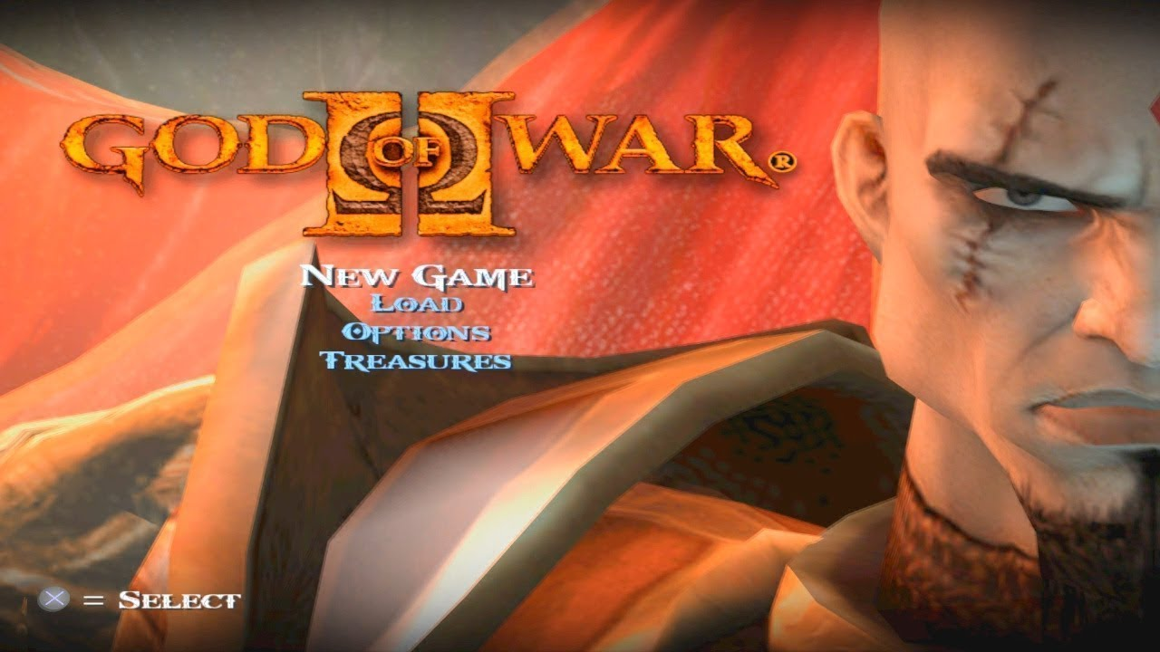 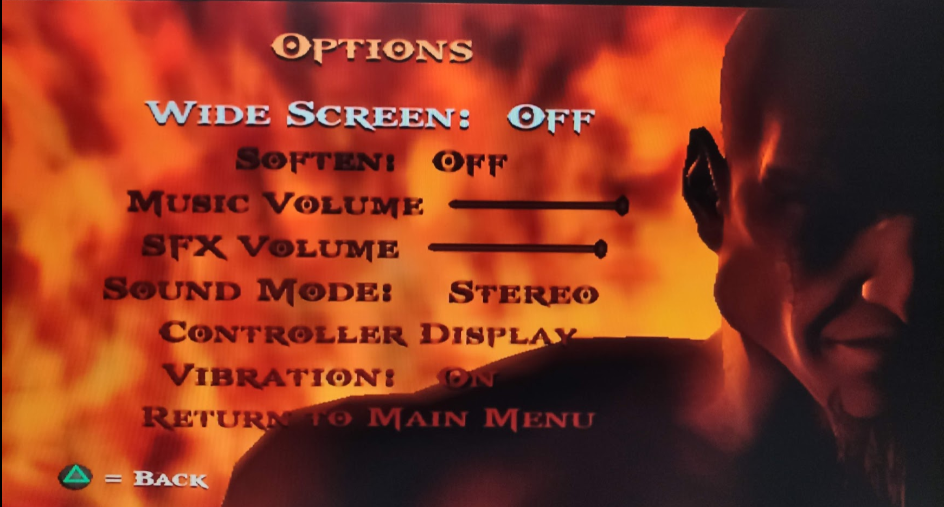

God of War 2 Main Menu God of war 2 Option Menu

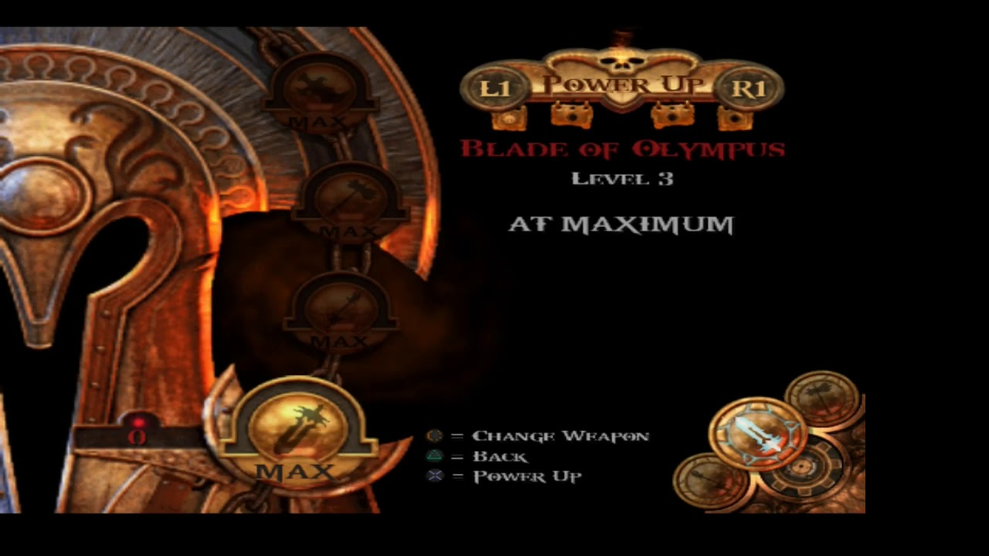 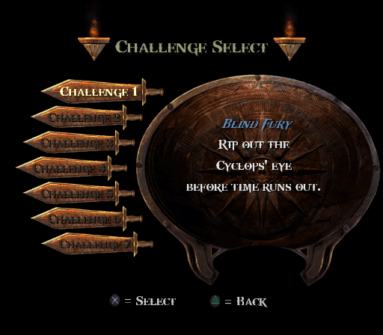

God of War 2 Upgrade menu God of War 2 Challenges Menu

Bonus Costumes:

**Cod of War**: Kratos plus a fish costume equals the Cod of War!

**Hydra Armor**: Wear armor forged from the scales of the deadly Hydra.

**Dark Odyssey**: Embark on a Dark Odyssey with a warrior suited to the task.

**Athena:** Play the game as the Noble Goddess Athena.

**Hercules:** Now you can have the strength and the looks of Hercules.

**General Kratos:** General Kratos returns from the past, and is at your command.

**God Armor:** Wear armor of the God of War to inspire fear into your enemies.

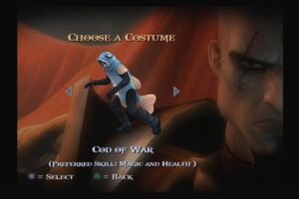 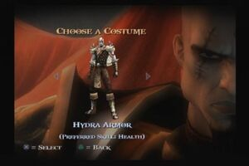

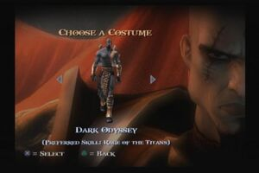 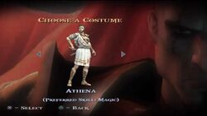

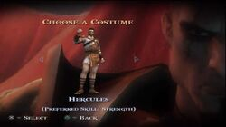 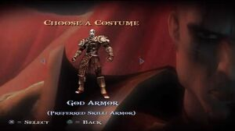

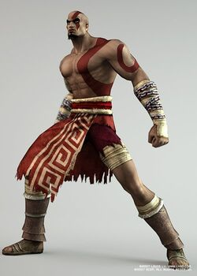

General Kratos

# Tasks and cast

**Developer:** Santa Monica Studio

**Publisher:** Sony Computer Entertainment

**Directors**: Cory Barlog, David Jaffe

**Producer**: Steve Caterson

**Designer:** Cory Barlog

**Programmer:** Tim Moss

**Artists:** Stig Asmussen

**Writers:** Cory Barlog, James Barlog, Marianne Krawczyk

**Composers:** Gerrard Marino, Ron Fish, Mike Reagan, Cris Velasco

**Cast:**

Leigh Allyn Baker - Lahkesis, Bathhouse Girl #2

Corey Burton – Zeus

Terrence C. Carson – Kratos

Cam Clarke - Hercules (credit only)

Robin Atkin Downes - High Priest of the Fates

Michael Clarke Duncan – Atlas

Paul Eiding – Theseus

Greg Ellis - Rhodes Soldiers, Spartan Soldiers

Keith Ferguson - Boat Captain

Harry Hamlin – Perseus

Linda Hunt - Narrator, Gaia

Bob Joles - Barbarian King, Icarus

Josh Keaton - Last Spartan

Peter Lurie - Rhodes Soldiers, Spartan Soldiers

Jennifer Martin – Euryale

Alan Oppenheimer – Prometheus

Khary Payton - Rhodes Soldiers, Spartan Soldiers

Carole Ruggier – Athena

Armin Shimerman - High Priest of the Fates

Susan Silo – Clotho

Fred Tatasciore – Typhon

Debi Mae West - Atropos, Bathhouse Girl #1

Marc Worden - Last Argonaut